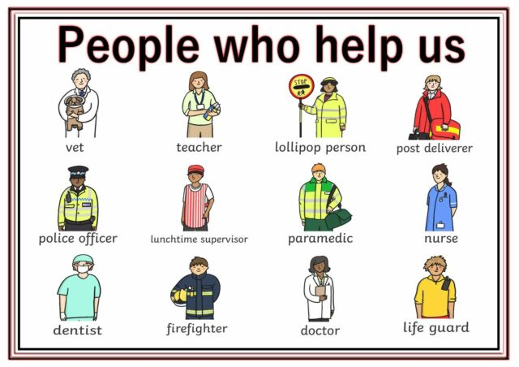





We love to hear about what the children have been up to at home and if you have noticed new learning. You can pop a note in your child’s bag or email us at:

[tanya.parker@ntlp.org.uk](mailto:tanya.parker@ntlp.org.uk) [helen.mason@ntlp.org.uk](mailto:helen.mason@ntlp.org.uk)

**Hidden Heroes.**

Next term our topic will be all about the special people in our lives who help to look after us and keep us safe. We have already booked a visit with mountain rescue, Mr Bell who helps us on the crossing and the fire service.

If you are a doctor, midwife, police officer, dentist or have another career we have not named here and you can spare 20 minutes to come and chat to the children about your job we would be thrilled to see you.

Please let a member of staff know if you can volunteer. Thank you.

**Our Core Values make Southridge a special school**.

We have been thinking carefully about our core values: **Friendship**, **Honesty, Respect, Kindness** and **Responsibility**. We all agree thatfollowing these values makes us all feel happy and safe. We have also discussed how we can use our core values at home in the holidays.

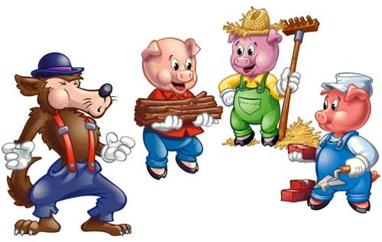

Have Fun at Half Term!

We will look forward to seeing you on our return to school

Monday 25th February.

The Early Years Team.

**This week…**

The children have had fun putting their ‘own stamp’ on the story of The Three Little Pigs. They came up with all kinds of wonderful ideas to change the ending of the story and have written their lovely ideas down. We have been so impressed by them all.

Maybe you and your child could chat about an alternative ending to a favourite story you enjoy at home. Your child might want to write or draw their ideas. As always, we would love to hear about this.



**Southridge First School**

**Reception Newsletter 15.2.19**