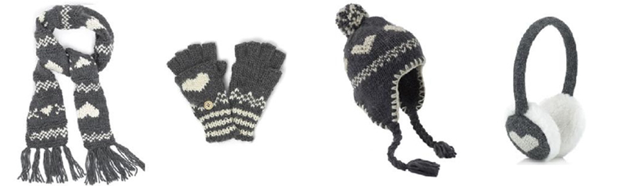

Naturally at this time of year we have lots of hats, scarves and gloves in school and it is easy to lose them. This weekend can you make sure these items are named so that if they do stray they can be returned to their owner ASAP.

We are running **very low** on girls and boys spare underwear, tights and socks which we use for little toilet accidents and falls in the damp weather. If your children have any spares at home or any they may have grown out of can we please have them? Thank you.



A big thank you to parents and grandparent who supported us on our church visit and our panto trip. Without your support these trips could not go ahead, so **thank you**.

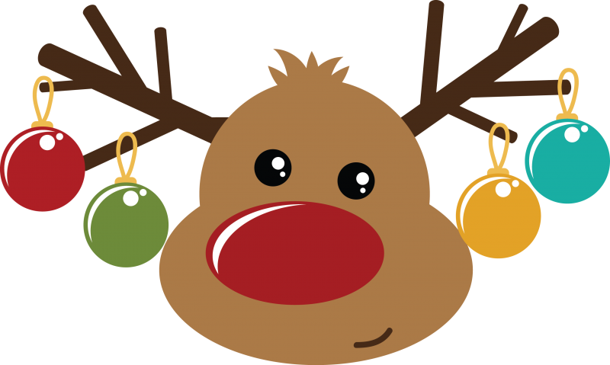

We would like to send out huge thanks to the PTA who work extremely hard for our children and school. The Christmas fair was a great success we had a fantastic turn out and I’m sure you will agree it was a lovely evening enjoyed by all.

Also thank you for all of your kind donations to the Christmas fair. It is very much appreciated.

Christmas crafts

On Friday last week Nursery, Reception and Year 1 children we

Apologies for the error in last week’s newsletter!

We look forward to seeing you at one of our Christmas performances on Friday 14th December **9.30 am or 2pm.**

Reception Newsletter 13.12.18

