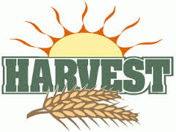

Harvest Assemblies

Our Harvest Assemblies are taking place on the dates listed below. As we will have lots of children in the hall and space is tight, we would ask that only ONE parent per family attend please.

Reception Harvest Assembly – on Wednesday 25th September at 9.10am. Parents of children in Reception class are welcome to stay on at drop off time in the morning to listen to the children sing their Harvest song alongside the whole school We will begin at 9.10am in the school hall so after dropping your children please walk around to the front entrance of school to enter the hall. You are welcome to stay for coffee afterwards which is a lovely opportunity for our new parents to get to know each other.

KS1 (Year 1 & 2) Harvest Assembly – on Wednesday 25th September at 2.30pm

KS2 (Year3 & 4) Harvest Assembly – on Thursday 26th September at 9.10am

This year we are again asking families to help us support a local charity 'The Bay Foodbank'. This charity aims to provide emergency food provision to individuals and families experiencing financial crisis due to bereavement, benefit delay, illness, redundancy etc. For more information go to www.thebayfoodbank.org.uk. The Bay Food Bank would be extremely grateful for donations of tinned and dried foods e.g. pasta, pasta sauce, rice, vegetables, tuna, breakfast cereal, dried milk, tea bags, sugar, biscuits, cooking sauces, rice pudding etc. Children should bring in their donations from Thursday 19th September please.

