**Dates for Diary!**

Reception will be performing a Christmas show (Jesus’s Birthday) with Nursery on Friday 14th December in the morning and again in the afternoon. Please see the lists on the doors at the entrance to Reception and sign up for the morning **OR** afternoon performance **Due to hall space, only two adults per child please and you can only attend ONE performance.**



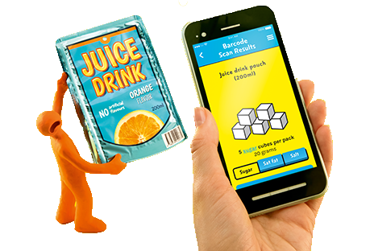

**The children have settled well at lunchtimes** so we are taking the next step in encouraging them to make really healthy choices independently.

We currently guide the children to have a vegetable or salad side of their choice with their main meal but we would like to ensure that they choose and eat a wider range of salad and vegetables which they select without prompting.

If you would like to support us at home by trying different things and talking about what makes us healthy see below.

Go to <https://www.nhs.uk/change4life-beta/recipes#EjP49HHdUhiKXfxb.97> for recipe tips to make with your child. (Send us your pictures.)

Be Food Smart wherever you are.

There is a FREE Be Food Smart app to download which can be found at the above address.  
Download and start scanning!

[image: https://campaignstorage.blob.core.windows.net/change4life-beta/production/uploads/ckeditor/pictures/197/content\_App\_Store\_new.png](https://www.nhs.uk/change4life-beta/be-food-smart-ios" \t "_blank)

[[](https://www.nhs.uk/change4life-beta/be-food-smart-ios)](https://www.nhs.uk/change4life-beta/be-food-smart-ios" \t "_blank)

[image: https://campaignstorage.blob.core.windows.net/change4life-beta/production/uploads/ckeditor/pictures/198/content\_Google\_Play\_new.png](https://www.nhs.uk/change4life-beta/be-food-smart-android" \t "_blank)

[[](https://www.nhs.uk/change4life-beta/be-food-smart-android)](https://www.nhs.uk/change4life-beta/be-food-smart-android" \t "_blank)

Read more at https://www.nhs.uk/change4life-beta/food-facts#xe7SESaUXML4WwJk.99

In Literacy we have been learning about the Hindu festival Diwali.

In Number work we have been counting objects to 10, 20 and beyond.

How many Pudsey spots can you count or draw?



Reception Newsletter 16.11.18



**We had a wonderful day raising money for children in need. Thank you for your support in getting the children dressed up and for all your donations of money.**

We have:

* Had a sportathon
* Made split pin moving Pudsey’s
* Counted the spots of different items in number work
* Played hide and seek with Pudsey to develop positional language
* Learnt about helping hands.

We have had lots of fun!

Keep sending us in your quotes about children in need. You may get some more following today’s events and whole class teaching.