Put the hat on.

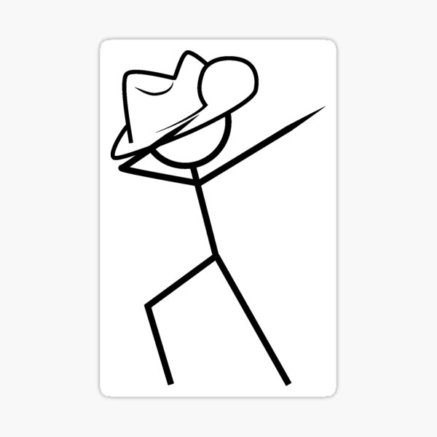

Put them on.

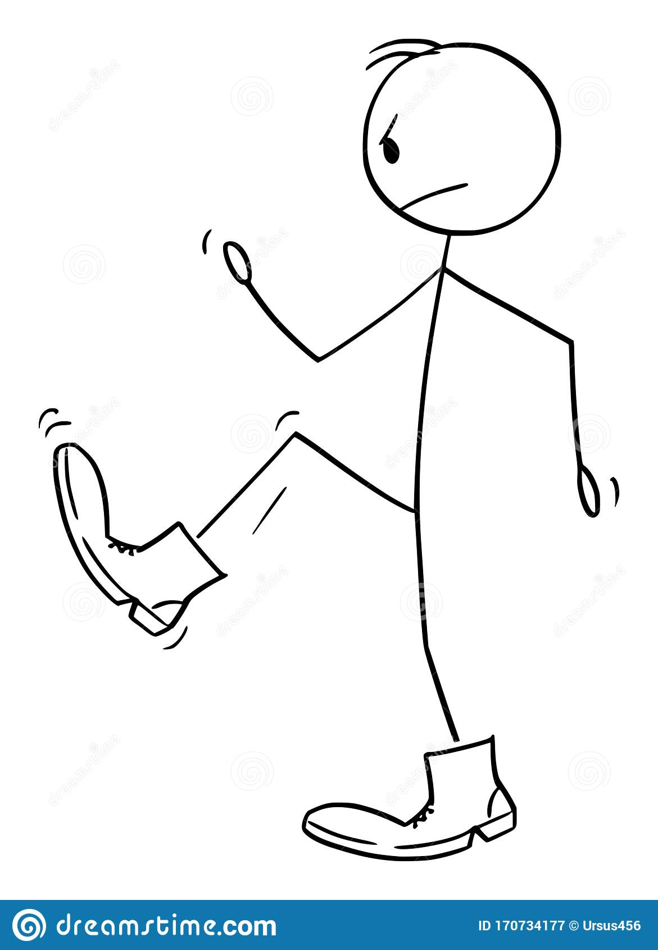

Put it in.



***Before you start? Do you know the speed sounds and tricky words? I need to read this with confidence.***

**Learn these red words before reading. (You may want to cut them up to play games with and practise).**

**Put the**

**Revise speed sounds chart / grid**

More practise needed of **sh ch th qu ng nk**