Maggie Maths Tuesday
10 | 20 | 30 | 40 | 50 | 60 | 70 | 80 | 90 | 100
I have 3 groups of ten… so that’s …..10….. 20….. 30.
So, I have 30 pieces of pasta!
Can I count in 10s?
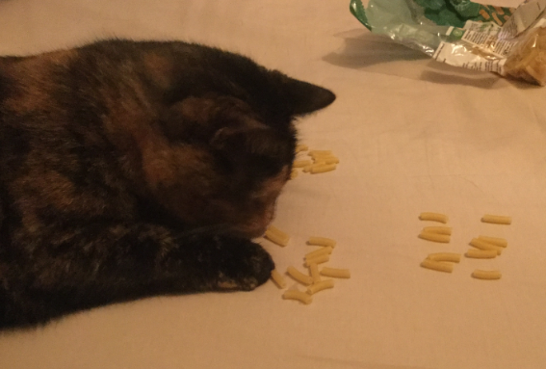

Maggie has been busy counting out the pasta and made groups of ten. Can the children tell Maggie how many pieces of pasta are in each picture by counting in tens?
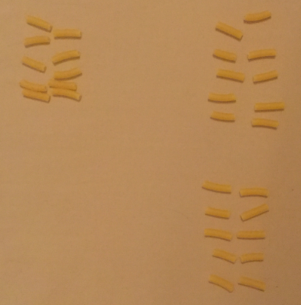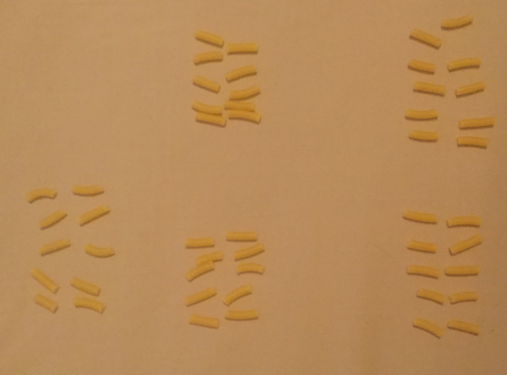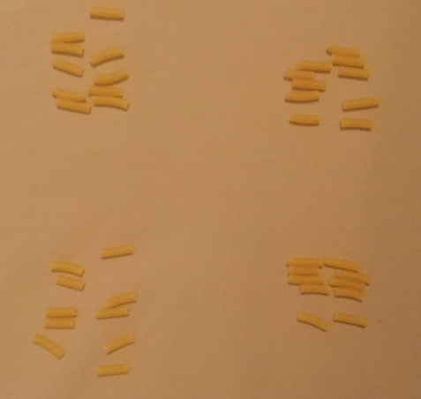

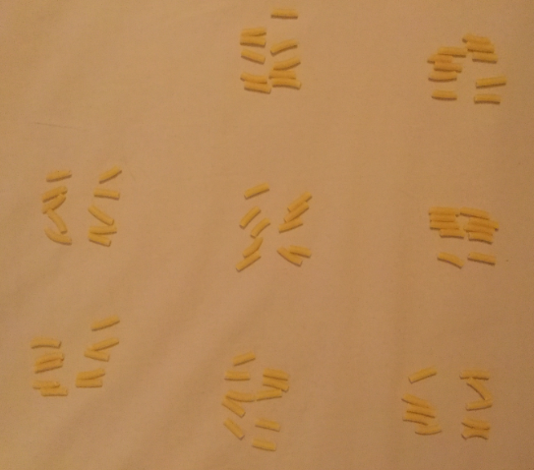

Challenge:
Make your own pasta piles of ten and see if you can count in tens to 100 and back.

