

Next Friday is our Christmas performance –13th December

**Miss Flitcroft’s Class – parents must attend the morning performance at 9.30am** where children will perform with the morning Nursery class.

**Miss Parker’s Class – parents must attend the afternoon performance at 2.00pm** where children will perform with the afternoon Nursery class.

**There are 2 places for each family** (due to fire regulations).

Remember its Christmas jumper day and children will need a plain black t shirt under their jumper.



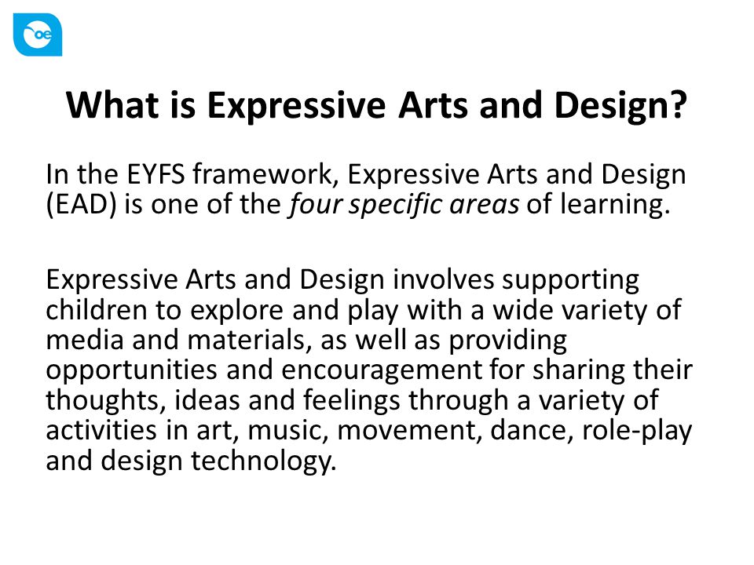



We’d love to receive your messages about how the children have been practising. ‘Being Imaginative’ is such a super area of learning at this time of year to capture those songs they may be singing in the bath or acting out with their toys.

Thank you to everyone who has supported our wonderful Christmas fayre. The funds that the friends of Southridge raise goes towards so many valuable resources for the children.





**Our Christmas Party Day is on Tuesday.**

We are off to the Northern Stage in the morning so please be prompt at drop off. Children will come back to school after lunch time and will have a packed lunch containing their favourite sandwich, as requested by you at the start of the year.

In their book bags there will be a brown paper bag for you to include a small party tea for them for the afternoon. We will collect these in the morning at drop off so please put names on the bags.

This should include a small savoury snack (probably not a sandwich as that will be what they have for lunch), a festive cake, fruit and a drink.

**Remember to dress children appropriately in warm party clothes and sensible footwear** as it may be cold and label all clothing. In the afternoon we will be shattered so small party games such as pass the parcel and a Christmas film will be just the ticket to finish our very special day off.

**Reception Newsletter: 6.12.19**