Year 3 Science Week – ‘Journeys’

This week has been full of investigation, questioning, testing and exploring!

‘I feel like real scientist!’ ‘I love the rainbows best!’

‘I can’t wait to plant!’

We started the week building ‘Hoop Gliders’ linking to our learning about forces.

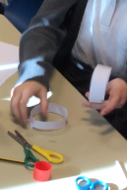 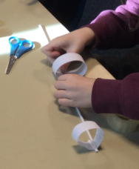 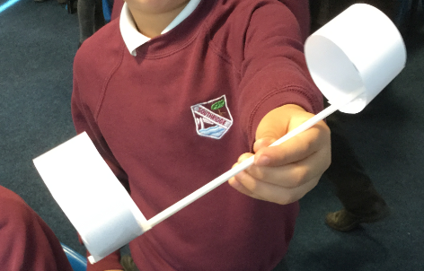

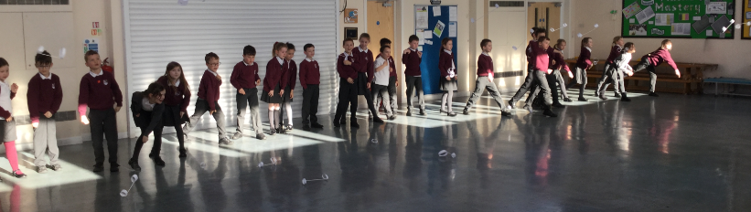

We got a pencil to pierce all the way through a bag of water… no leaks!

‘I can’t believe this works… it’s MAGIC!’

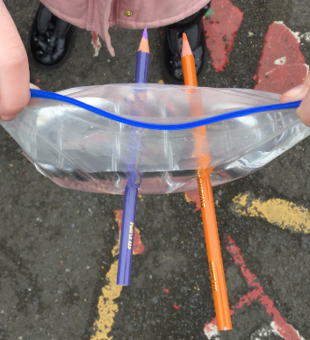 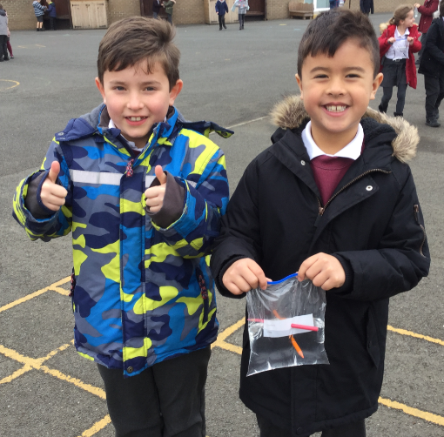 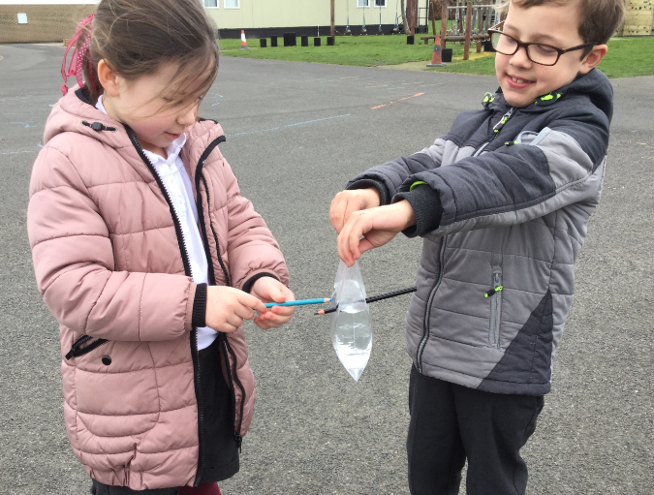

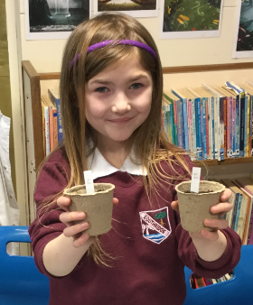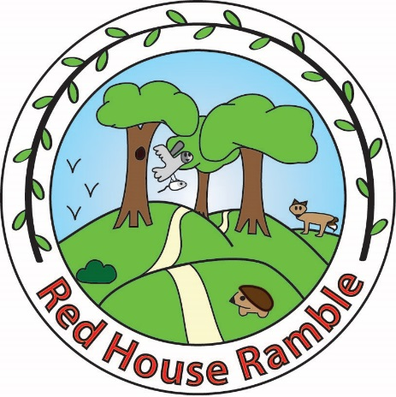

We loved working with the Red House Ramble group to plant a variety of wild flower seeds that will be shared between their garden and our school grounds once they have grown.

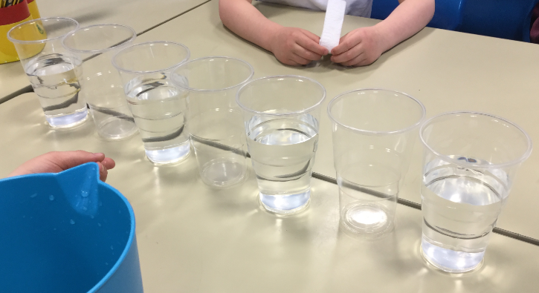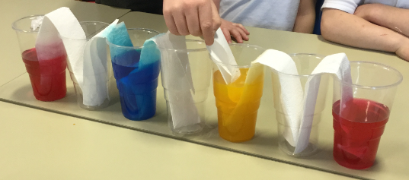

We were excited about making a ‘Rainbow Walk’ and linked it to our learning about primary colours and mixing in art!

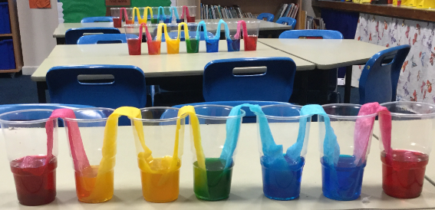

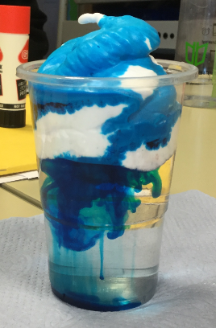 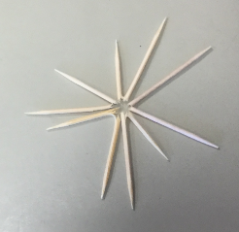 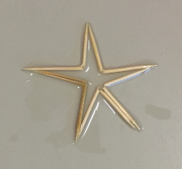

We discussed how rain clouds are formed and why it rains.

We turned broken cocktail sticks into a star with water and a little patience!

We have LOVED Science Week!!

Add water