Wednesday 25th March
Two and a half weeks old and doing well…
We are doing well, we have lots to eat and keep getting bigger (and a little hairier) each day!

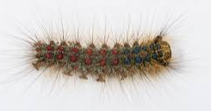
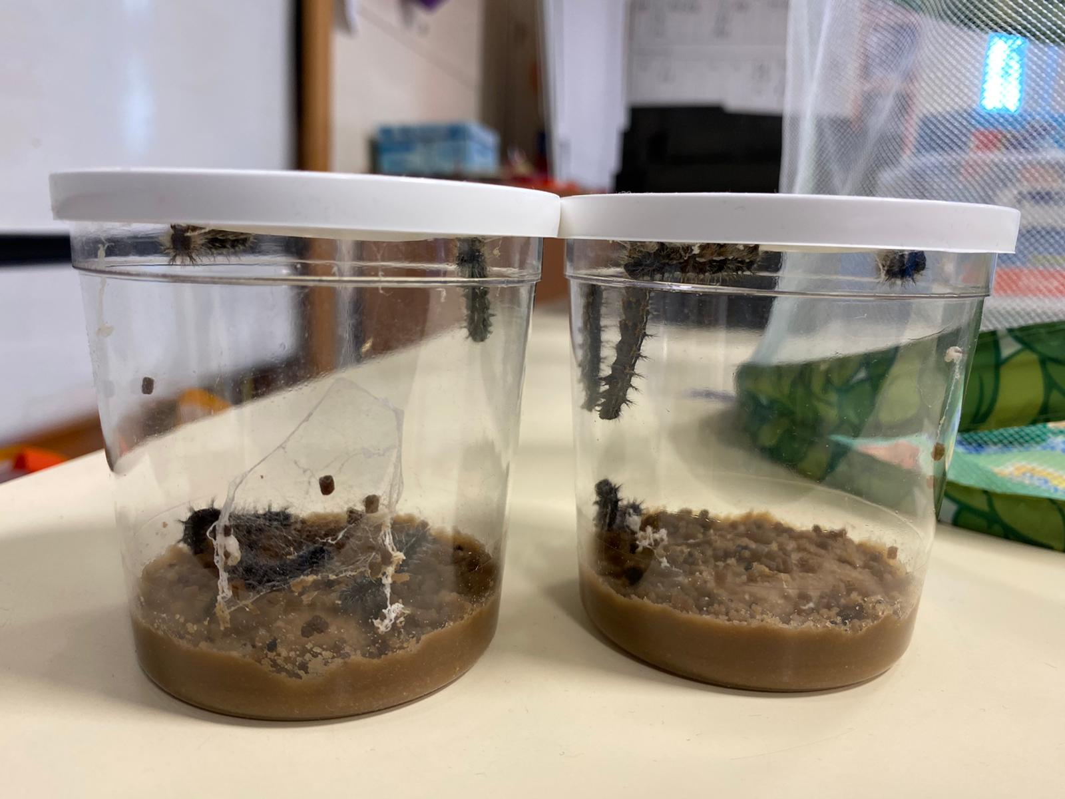
When we get to the lid, we will hang upside down and form our own chrysalis … I am so excited!
We are making our way up to the lid but keep getting peckish… so we creep down for a little snack, yum!
Ideas:
Read the story of The Hungry Caterpillar by Eric Carle
Draw your own picture of the caterpillar and then label the different parts using your fabulous phonics.
(Challenge: write a sentence or two about the caterpillar).
Ask a question about the caterpillars and ask a grown up to help you find the answer using the internet or books.

