

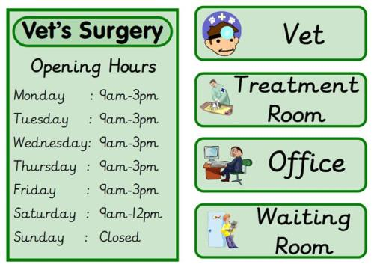

In Literacy we have been learning about pets as part of our vets role play. We have made lists of what things they need to stay healthy. This has given us another chance to practise our sound talk and learn about different genres for writing.

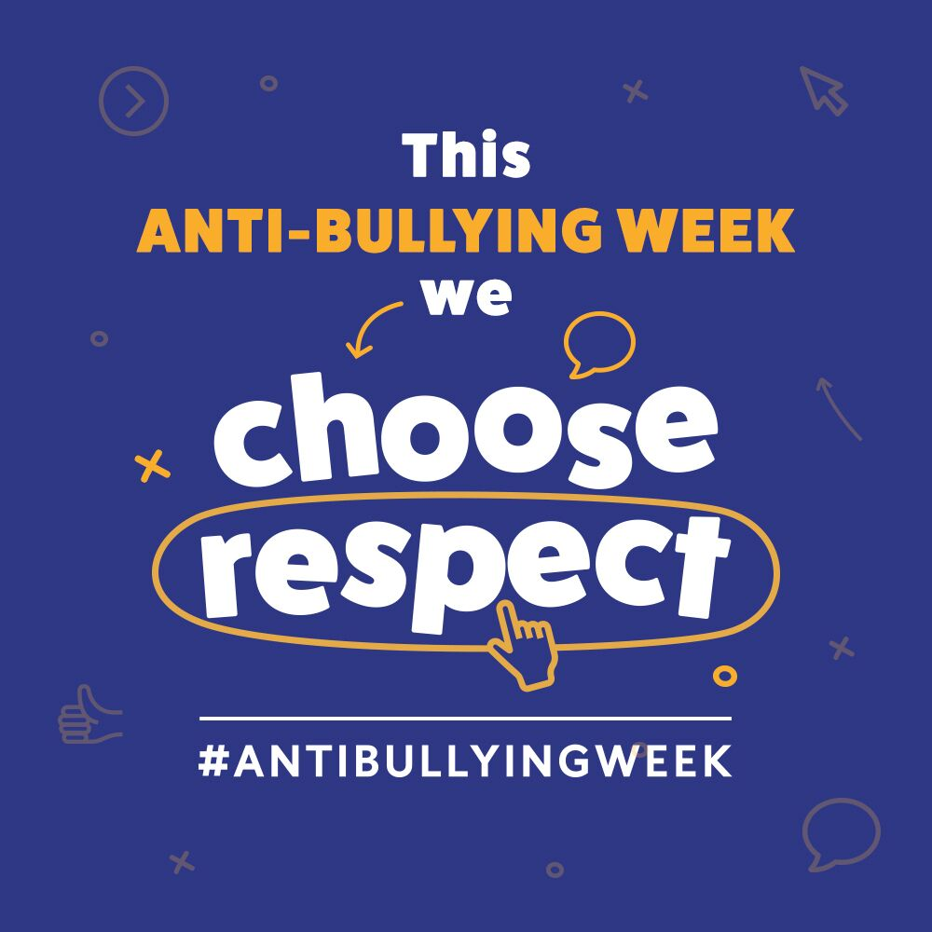

**Reception Newsletter: 11.11.19**

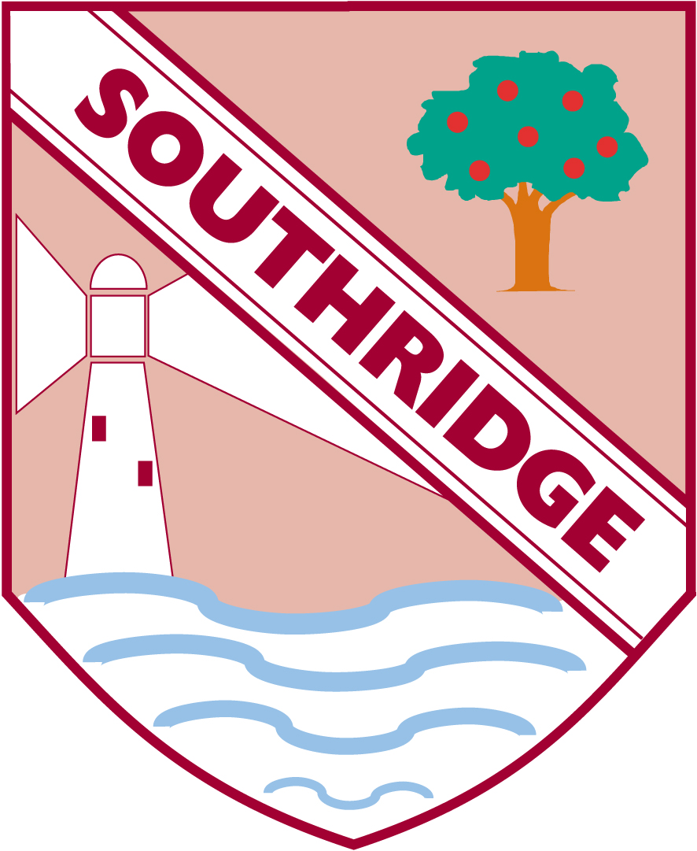



Can I count a random group of objects? What strategies did I use?

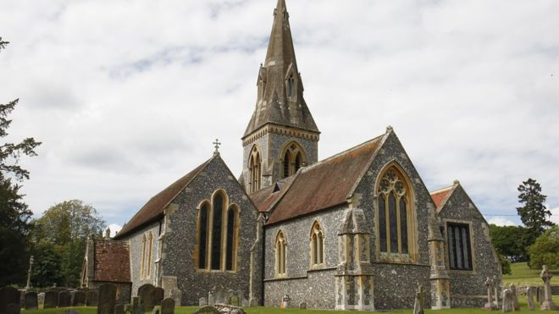





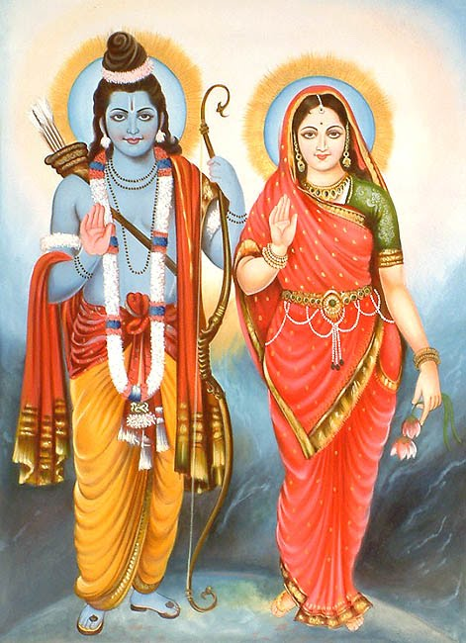

Our Enrichment Day was all about Diwali this week.

We made Rangoli Patterns

We made Diva Lamps

We learnt the story of Rama and Sita.

We have danced to Diwali songs to celebrate.

We have built different places of worship in the construction area with blocks and Lego.

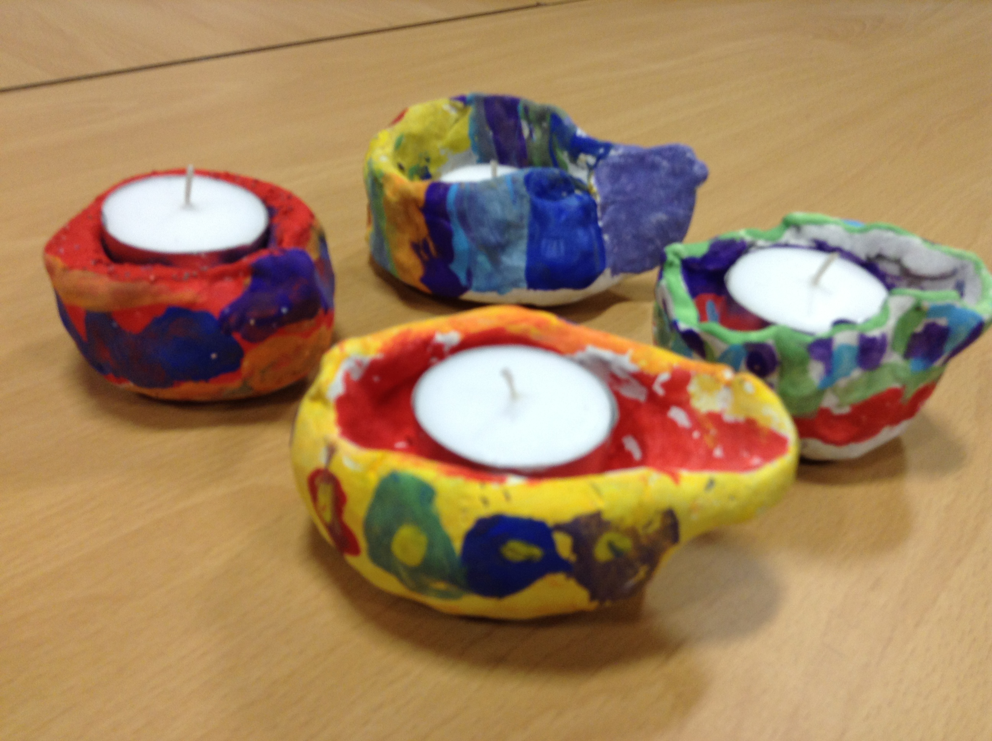

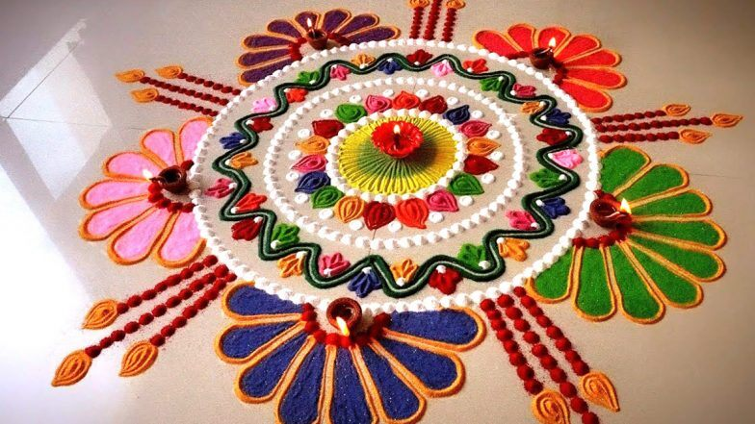

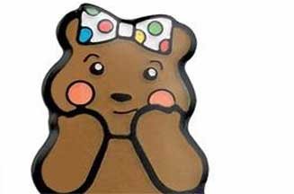



We will focus on this more as well on Friday as it is Children in Need Day. Don’t forget to wear active clothes as we will be working out and getting healthy.

This week has been Anti Bullying week.

As part of our PSHE curriculum we have been celebrating difference.

It is okay to be different.

We should not make fun of anyone who is different to ourselves.

We should respect other children’s ideas even if they are different to ours.

We learnt a new song.