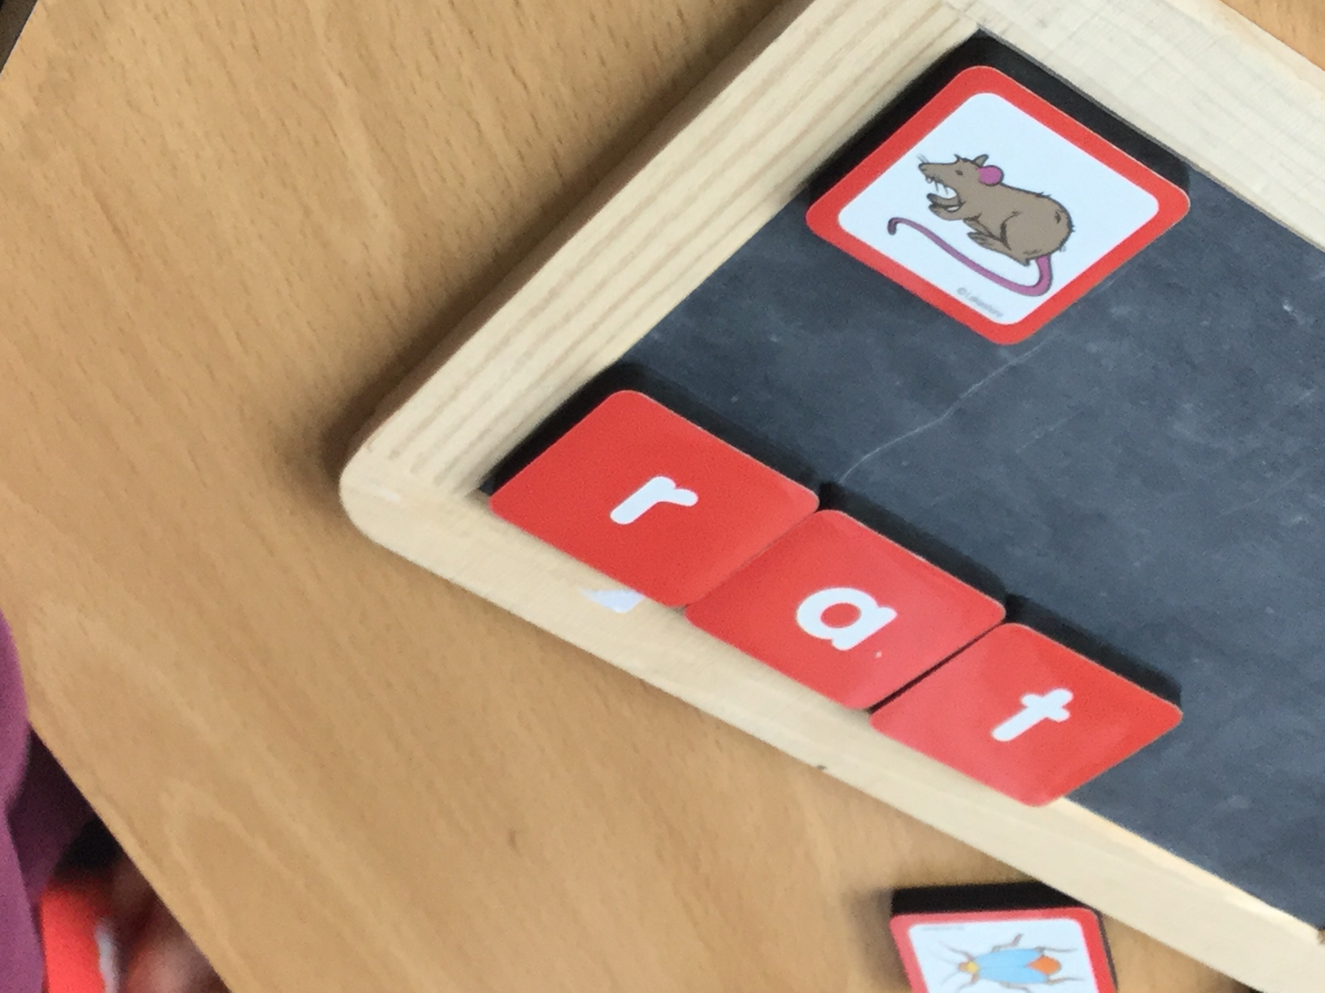

We have been word building.

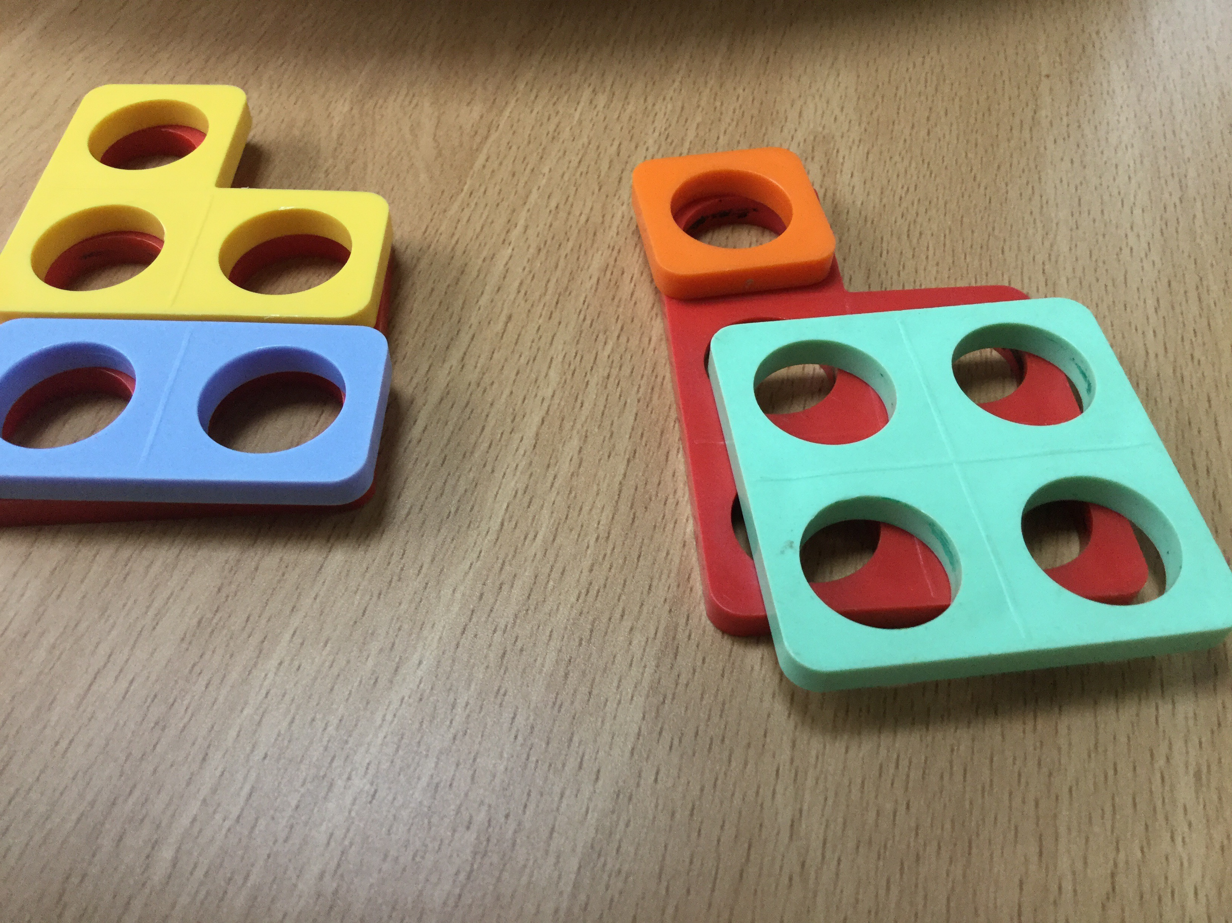

We explored different ways to make 5 and 10.

Sometimes with just 2 Numicon pieces and sometimes with 3

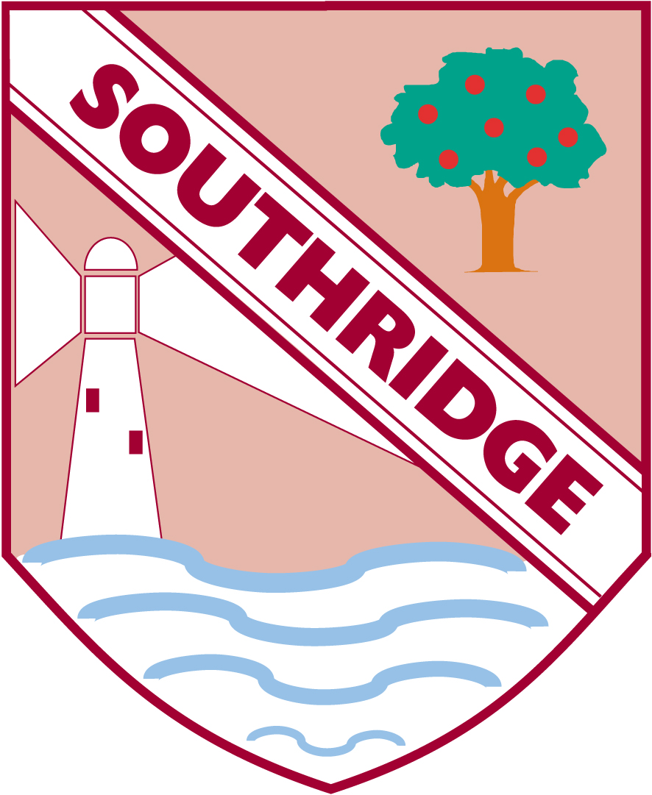

**Reception Newsletter: 4.11.19**

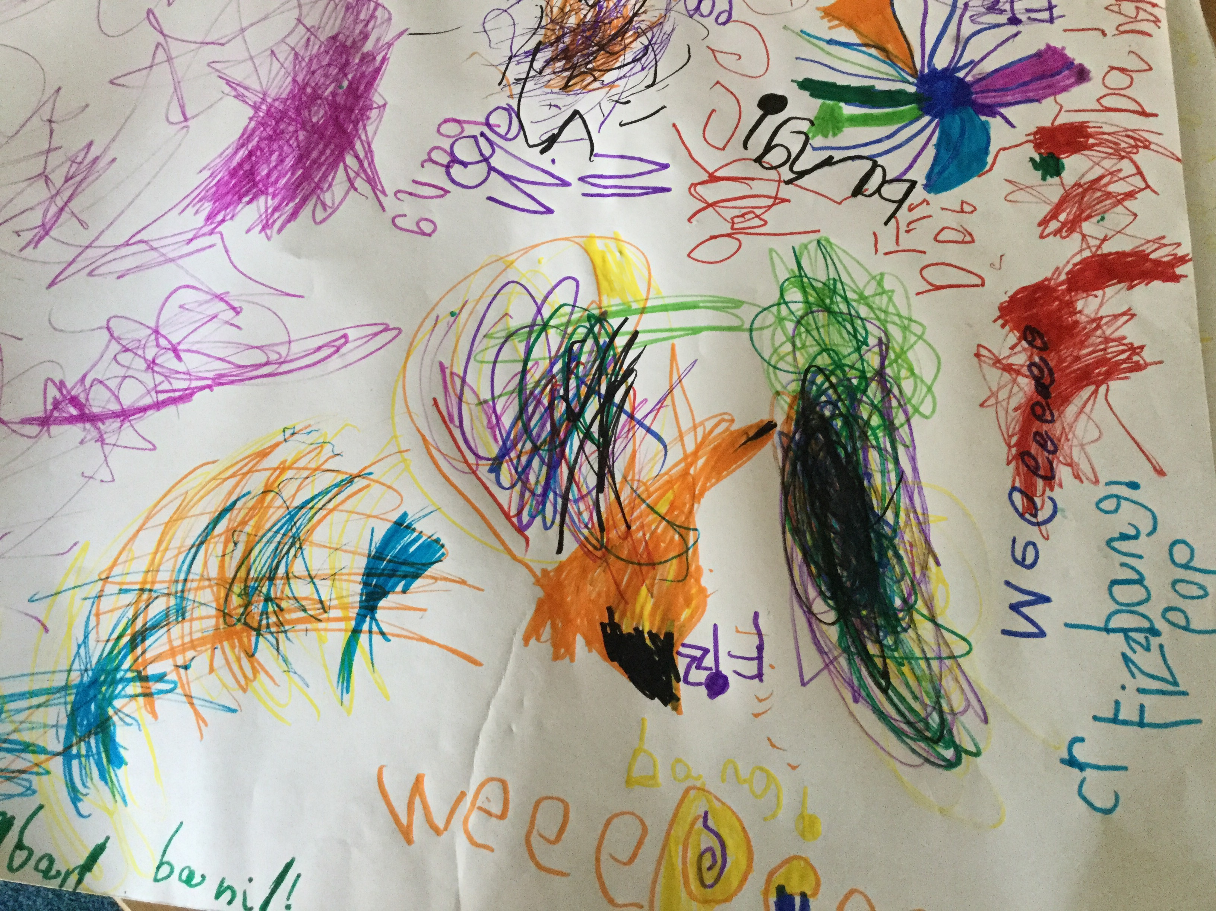

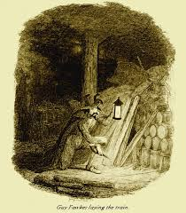



Welcome back!

Our week began with a BANG! We began on Monday making our own firework murals and practised our sound talk for the noises they would make.

We learnt about how an exclamation mark (which we also like to call ‘ a shouting stick’ ) can enhance our reading and writing.

We labelled our joint team murals with the noises. This gave us a chance to write down our practised sound talk.

Outdoors we put on a firework display of a different kind. Using streamer and ribbons and our voices to make the noises.

On enrichment day we became history detectives!

Do you know who this man is?

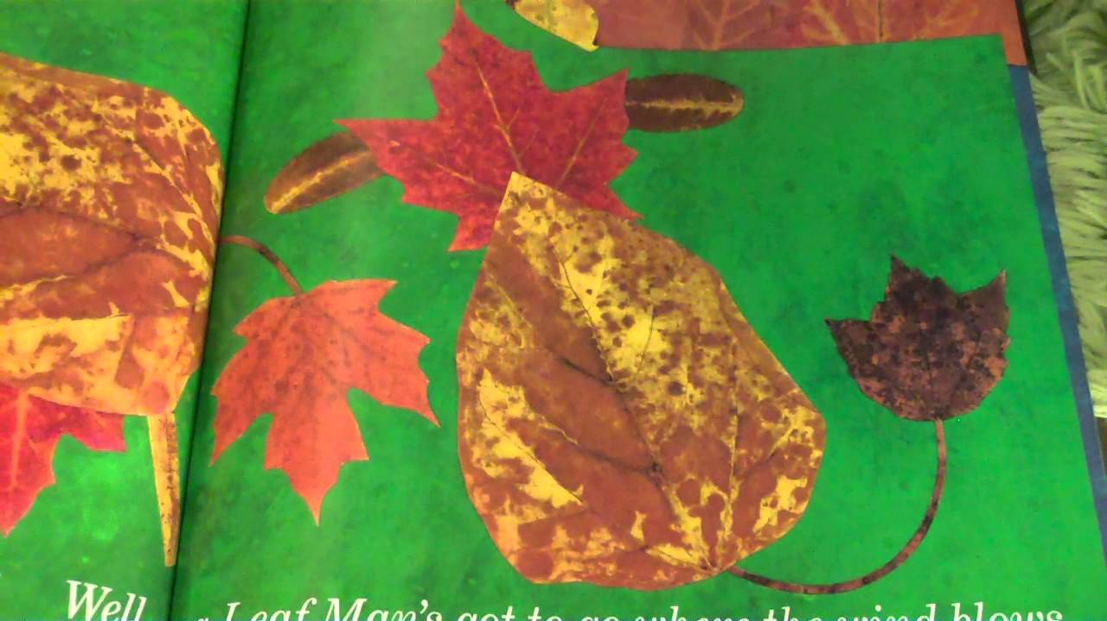

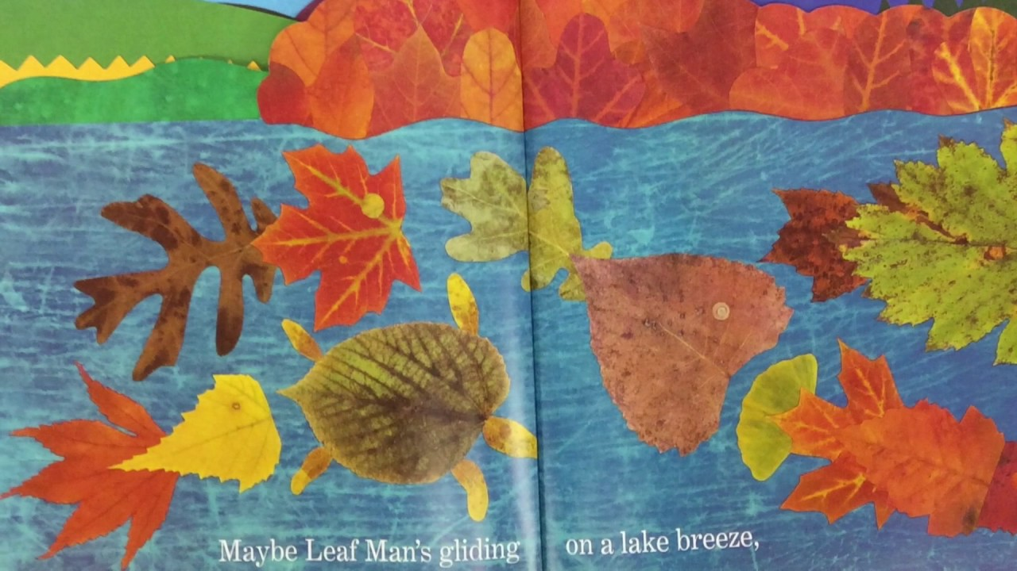

We have read the story ‘Leaf Man’ by L. Ehlert and discussed the characters that emerge in the wonderful illustrations on each page.

At first a pile of leaves is not what it seems as the children look closely at some of the images that appear from the pages.

Outside we collected different coloured, sizes and shaped leaves. We problem solved how we could dry them off and then made our own collages using the leaves we collected.

We learnt how to use PVA glue properly with a glue spreader which was another important skill to learn when fixing and joining things together.

We also learnt a season’s song which the children thought was very catchy. You might like to play it at home.

<https://www.youtube.com/watch?v=8ZjpI6fgYSY>