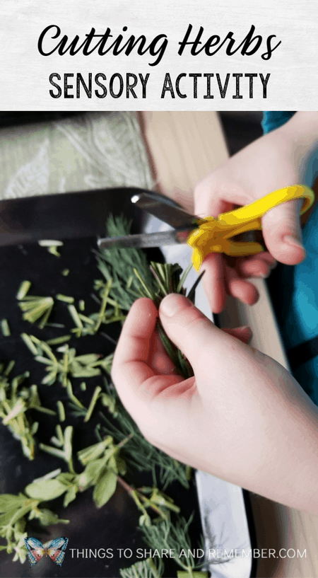

**Exploring Herbs –** Perhaps you have some herbs, or you can buy some from the shop. Explore them using all the senses. Use scissors to cut them up. Remember the rhyme which helps us when we’re cutting: Finger in the bottom, thumb in the top, open them up and chop, chop, chop.

**Drawing with Carrots –** Tape a pencil to a carrot. Encourage children to draw/write. The carrot makes a nice chunky grip for children to hold.



**Potato Mashing –** Have a go at mashing potatoes or even peas! You could use the potato masher in paint for printing.



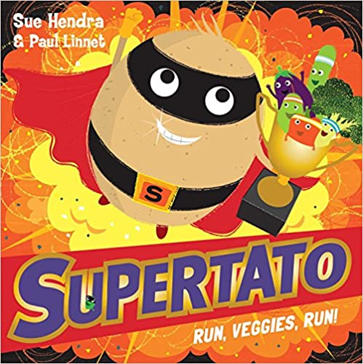

**Reviewing Sounds -** You might like to use this week to review the sounds we have learnt so far. They are: **m a s d t i**

Check out the Ruth Miskin parent video on YouTube – How to say the sounds.

**Supertato Target Practice -** Make a pyramid of cans. What can you use to knock the cans over? How many did you knock over?

**Sound of the week -** You can watch Geraldine Giraffe learning ‘n’

<https://www.youtube.com/watch?v=IQsCAyq-axU>

**Nursery Rhyme of the Week**

The Grand Old Duke of York

Can you sing this song every night at bedtime?

**Home Learning Ideas**

**Week beginning:**

**11th January 2021**

**Supertato continues to be our source of inspiration this week! Please look on the school website to hear a second Supertato story.**

[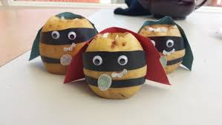](https://www.google.co.uk/url?sa=i&url=https%3A%2F%2Fcraftandothercrazyplans.com%2F2016%2F04%2F10%2Fsupertato-to-the-rescue%2F&psig=AOvVaw1r2L54H7eylW3KwBEkVE74&ust=1610016406025000&source=images&cd=vfe&ved=0CAIQjRxqFwoTCLClsdKQh-4CFQAAAAAdAAAAABAD)

**Make a Supertato –** Can you turn a potato into a superhero?

**Reviewing numbers -**You will find a maths worksheet uploaded onto the school website. The shapes on this sheet are called Numicon. In school we use plastic Numicon shapes to provide a visual representation of number. Parents might find the first 2 minutes of this information video useful - https://www.youtube.com/watch?v=yYgwM5Z1tMo

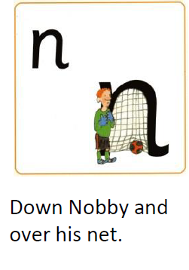

[](https://www.google.co.uk/url?sa=i&url=https%3A%2F%2Fwww.pinterest.com%2Fpin%2F414894184392042944%2F&psig=AOvVaw1Ksj27ctxSeKwoYUFXmjuL&ust=1610015290523000&source=images&cd=vfe&ved=0CAIQjRxqFwoTCOCekb6Mh-4CFQAAAAAdAAAAABAD)

Keep a look out on the school website for additional home learning materials. Thanks for your support!