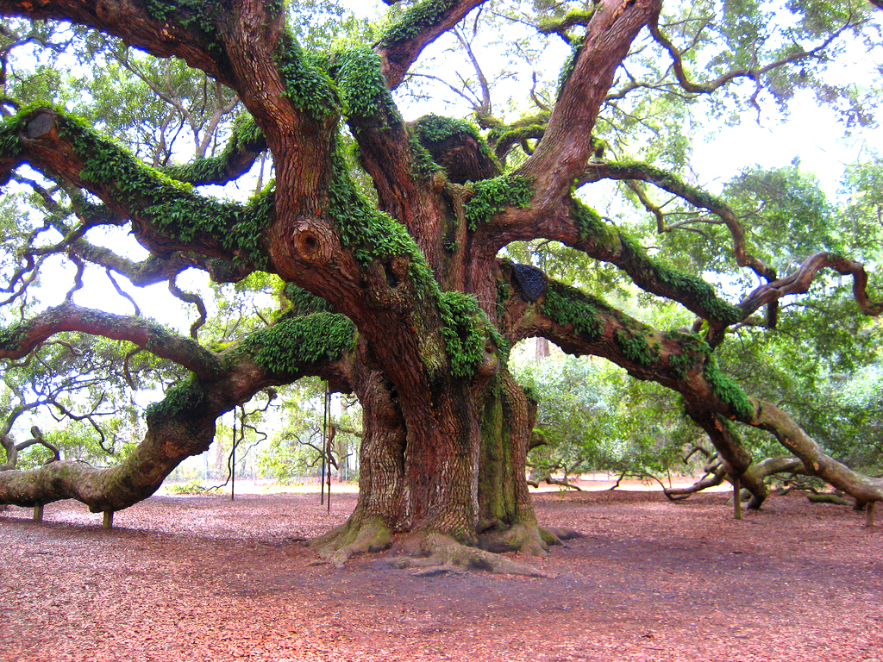

Imagine you are out for a walk in the woods one day when all of a sudden you come across this gnarled tree. You start to take slow, steady steps towards it when you hear a sudden click, like a lock being undone. A small door appears to open on the side of the tree and you can see a definite light glowing from within …

Write an imaginative story about what could happen when you come across this tree.
Look to include a range of description, action and dialogue.
Use lots of good WOW words for description.
Use a range of connectives to link your sentences.

