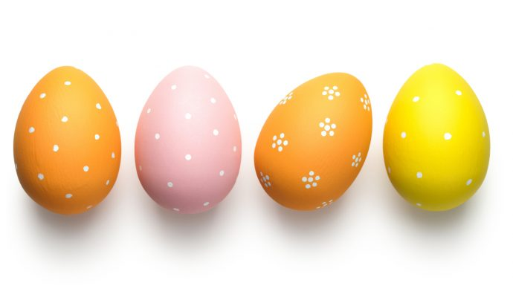

The Reception team would like to wish you all a very happy Easter.

Last week’s attendance winners were…

**Mrs Mason’s class.**



Weekend/Holiday News.

We have added a Weekend News book to your child’s bag which will go home with children every Friday. The idea is to give children the opportunity to create a scrap book of news to share with us in school.

Children can start using this book in the Easter break if they would like to. They can draw pictures, stick photos, tickets or leaflets in. All children are at different stages with writing, some children might be able to write labels to go with pictures and some can write a sentence or two. The most important thing is that children should not feel pressured by this activity.

When writing children can refer to the speed sound chart in the front of their book to help them find the phoneme (sound) they want to write.

Encourage children to ‘sound talk’ the word they want to write e.g. s-w-i-m or p-ar-k. Ask, which sound can you hear at the beginning? Which sound can you hear next? Don’t worry if their spelling is incorrect, it is important to encourage them to have a go and be brave writers and make phonologically plausible attempts.

It doesn’t have to be perfect! We would much rather see a child’s independent attempts at writing than a sentence that is copied.

Please don’t feel the need to have this book filled, something on one page for the first week of the Easter holidays and something on one page for the second week will be great.



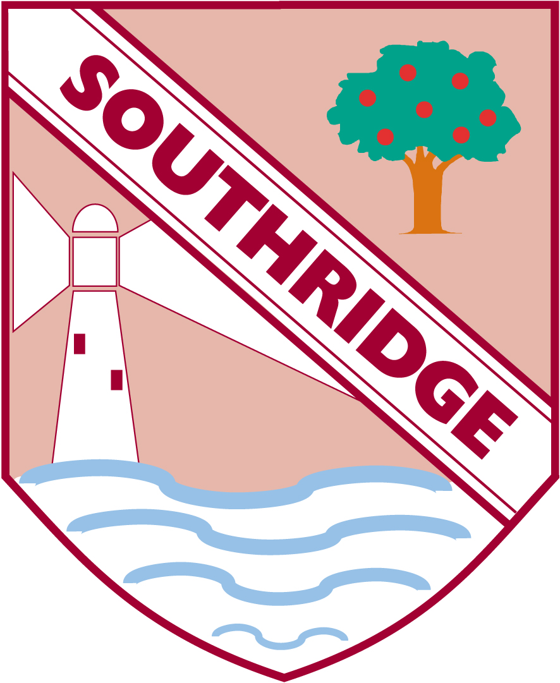

Southridge First School

Reception Newsletter 5.4.19