Day | 9-9.30 | 9.30-10.30 | 10.30 | 10.45-11.15 | 11.30 | Lunch | 1.00-1.30 | 1.30-2.30 | 2.30-300
M | Practise speed sounds from the front of reading books and green words  Tricky words | Physical Education | Story time and milk | Read my reading book and answer questions about the story | Maths songs, activities and ideas from online |  | Talk about the story frames from twinkle link | Write a paragraph using the describing words from the story. | Handwriting
T | Practise speed sounds from the front of reading books and green words  Tricky words | Technology  Computer activities. Use of digital tech | Story Time and milk | Select a number activity from Twinkl or Nrich website | Maths songs, activities and ideas from online |  | Makes something with the recycling and take pictures or draw it in my weekend book | Make up a dance to your favourite pop song. | Handwriting
W | Practise speed sounds from the front of reading books and green words  Tricky words | Select a number activity from Twinkl or Nrich website | Story Time and milk | Reading my reading book and related activities | Maths songs, activities and ideas from online |  | Talk about the story frames from twinkle link | Write a paragraph using the describing words from the story. | Handwriting
Th | Bake something nice to go with your story at story time |  | Story and milk | Be a scientist | Maths songs, activities and ideas from online |  | Make a role play:  Shop, classroom, tent, hairdressers, vets, doctors, theatre, puppet show, garage, workshop, police station. |  | Handwriting
F | Practise speed sounds from the front of reading books and green words  Tricky words | Paint a picture.  Do a college or print patterns like we learnt in the Laing workshop. | Read my parents or carers a story and story time using lots of voices and expression. | Maths on twinkl  Select ideas based on the : ELG 11 Numbers: Children count reliably with numbers from one to 20, place them in order and say which number is one more or one less than a given number. Using quantities and objects, they add and subtract two single-digit numbers and count on or back to find the answer. | Maths songs, activities and ideas from online |  | Reflect on your week and write about it with pictures or phots in your weekend book
 | Green words and tricky words |  | Any favourite story or one of pie corbetts over and over stories | 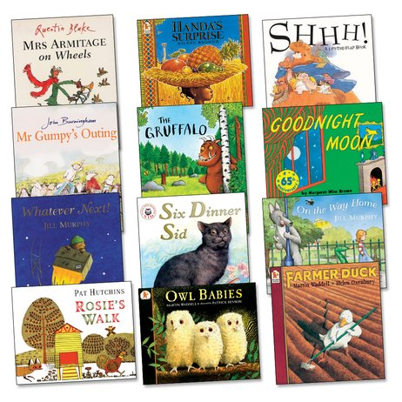 | Search Jack Hartman songs for counting forwards, backwards, in twos, fives, tens, to 100 .  3D shape song  https://www.youtube.com/watch?v=2cg-Uc556-Q  Number jacks on you tube. |  | Twinkl link for story frames.  https://www.twinkl.co.uk/resource/t-l-8624-story-settings-description-writing-frames |  | Handwriting patterns in families.  c o a d g q  l t u i y j k  m n h p b f r  S e z v w x

