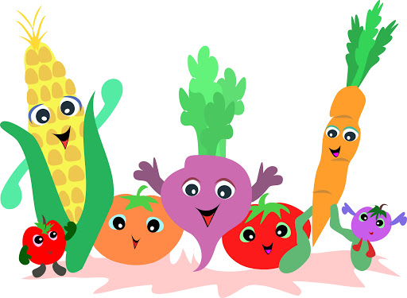

Choose your favourite vegetable and design your own Super Veggie.