[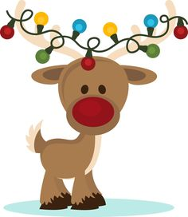](https://www.google.co.uk/url?sa=i&rct=j&q=&esrc=s&source=images&cd=&cad=rja&uact=8&ved=2ahUKEwiDnNSDtOPeAhXN2KQKHXw3BB0QjRx6BAgBEAU&url=https://www.pinterest.com/momamylynn/reindeer/&psig=AOvVaw0WdlGtvoNYv-jsLAWDH5eF&ust=1542818209630394)

**Christmas Fair.**

We would love to see you all at the Christmas fair starting straight after school on Friday 7th December. Children can come to school that day in Christmas jumper and/or Christmas accessories e.g. hats tinsel etc. in exchange for a donation for the Tombola or Bottle Stall.

**Please leave school bags at home on the day of the Fair.**

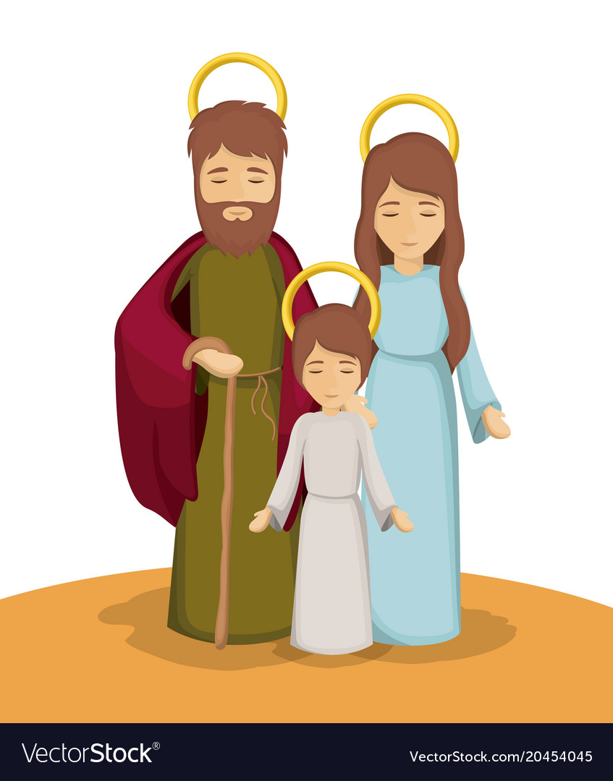

**Observations.**

For observations this weekend and helping us to assess the area of People and Communities maybe you could ask your child about the story we are telling in our Christmas performance.

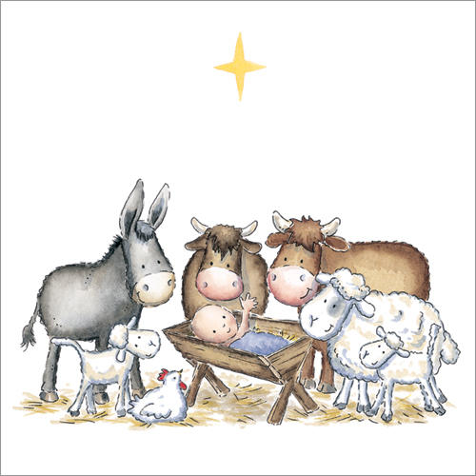

**Christmas Performance Reminder**.

If you have not already signed up, please see the lists on the doors at the entrance to Reception and sign up for the morning **OR** afternoon performance. **Due to hall space, only two adults per child please and you can only attend ONE performance.**

**Also**, please check your child’s bag for a small note explaining what their part will be in the performance and whether a costume is necessary.

. **Can you help?**

We would like to visit **St Mary’s Church on 6th December** but we need more adults to help when walking to and from the church or it will have to be cancelled. Miss Parker’s class would like to visit in the morning and Mrs Mason’s class in the afternoon. If you are available to help please let a member of staff know. Thank you.

Reception Newsletter 23.11.18

