Friday 3rd April

Shhh, they are getting ready…

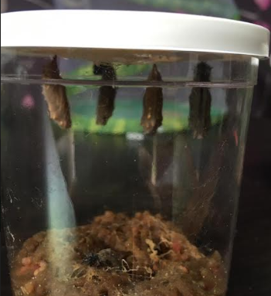 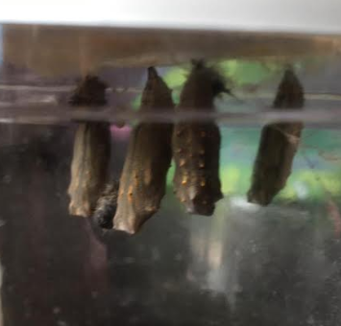

My chrysalis hard to put together!

Zzzzzz…

We are out of the cup and resting on the lid. Are we ready yet?

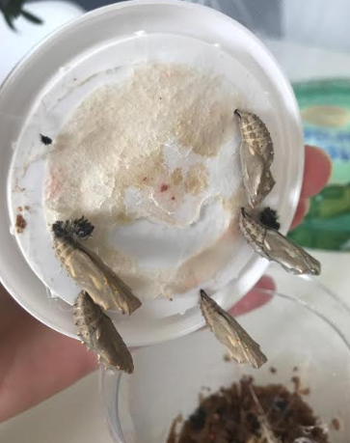 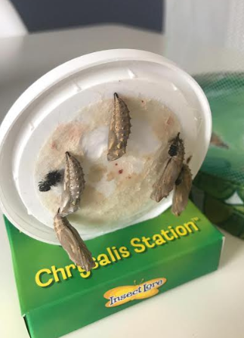

Ideas:

Draw what you think the butterflies will look like.

Tell us what food you think the butterflies need.