**Milk**

Milk in school is free for children until they turn 5. **After a child’s 5th birthday school does not receive milk for them. Parents need to pay for milk** online in order for their child to continue to receive milk in school. You should have received parent text message with details of how to pay for milk. If you need any more information about how to pay for milk please see the class teacher.





Each week the attendance scores in Reception are gathered to find the class with the best attendance. The winning class celebrates and gets the special attendance trophy for their class.

Last week’s attendance winners were

**Miss Parker’s Class.**

**World Book Day.**

We are looking forward to celebrating our love of books on World Book Day, **Thursday 7th March,** when children can to come to school dressed as a character from a book they particularly enjoy. It would be lovely if they could bring a copy of the book with them to share with us that day.

You might enjoy checking out the World Book Day website for fun activities, inspiration and fancy dress ideas. [www.worldbookday.com](http://www.worldbookday.com)

Children will be able to take part in a variety of activities on the day including a **Book Swap**. **Only one book swap per child**.

A Super First Week Back.

It has been a pleasure to welcome the children back to school this week and see how excited and confident they have been to share their half term news with us.

We have been made the most of the super weather this week and have taken our learning outside as much as possible. Hopefully the better weather will see an end to all of the winter bugs. We are keeping our fingers crossed for a healthy run up to the summer with full class attendance so that we can win the ‘attendance cup’ (especially in Mrs Mason’s class who only won the trophy once last term).

We will keep you updated.

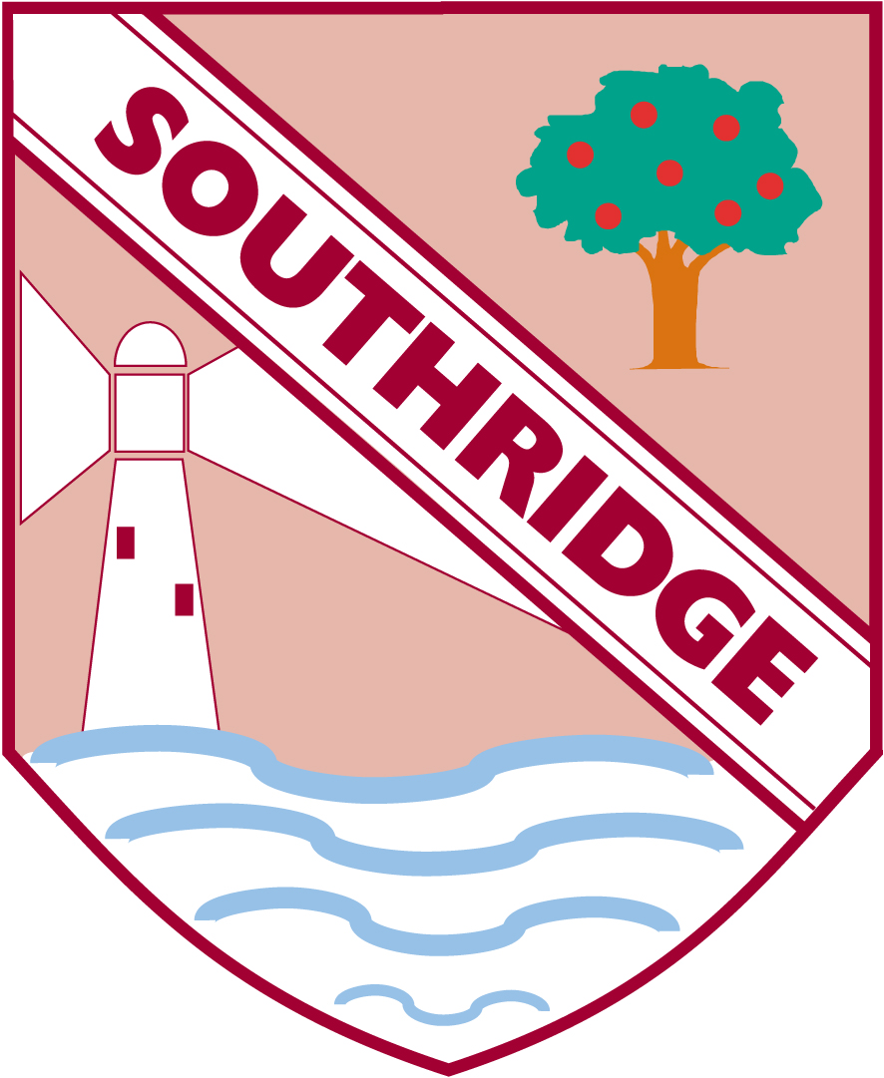

Southridge First School

Reception Newsletter 1.3.19

