**Just a reminder** that this event is coming up. For those of you who do not have feeders in your garden, now is the time to get them. It takes birds a while before they know where to find the food source so for you avid twitchers, you’ll need to give it time before you do your watch.

Alternatively, I was very impressed by the bird hide at Wallington Hall particularly with the woodpecker who looked so beautiful up close.

What is the Big Garden Birdwatch?

“2022 marks the 43rd RSPB Big Garden Birdwatch, which sees keen birdwatchers across the UK join the largest garden wildlife citizen science project by spending one hour tracking the birds they see in their gardens. Last year was the biggest Birdwatch ever, with over one million people taking part and counting more than 17 million birds”.

We have been estimating and investigating the concept of more and less this week.

Children have been invited to guess which they think has more in a set and then suggest how they know.

We are also at the stage where we are beginning to count in 2s .

Some useful songs to sing along to are below :

And for counting back in 2s

https://www.bbc.co.uk/teach/school-radio/nursery-rhymes-ten-fat-sausages/z6vh7nb

It was wonderful to hear all the children read this week. It was even more wonderful to hear that they thought they were real readers!

It is always a proud moment for us when the excited eyes knew that they could sound out a word.

Fabulous and thank you all for your support.

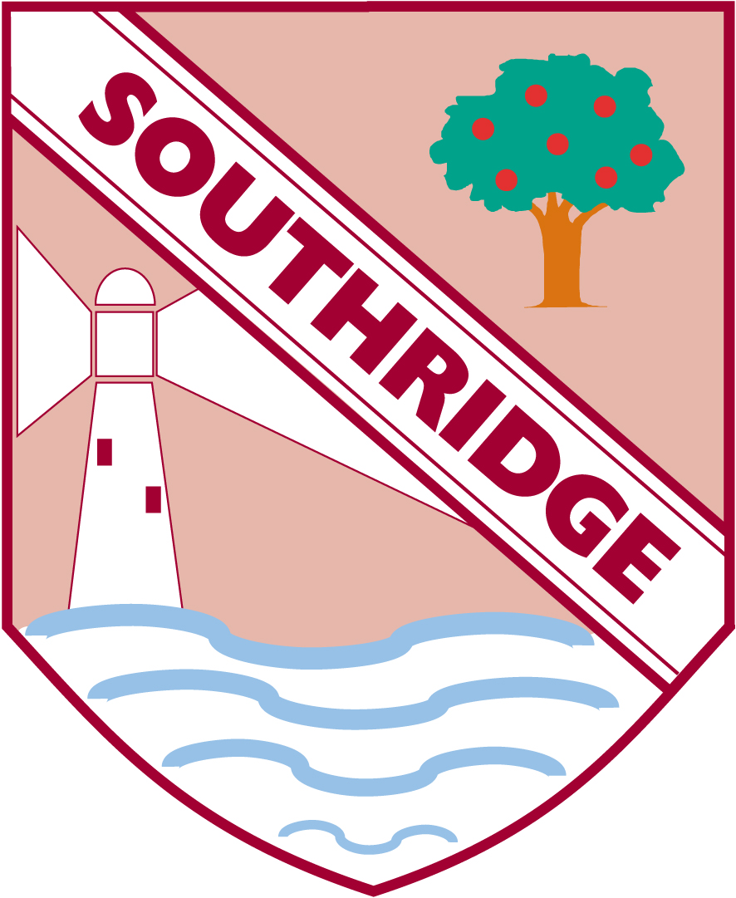

**Reception Newsletter: 21.1.22**

