Lego Club in Reception Classes
Week | Objective / Activity
Week1  SMC links, ethics of Zoos. | Stimulus: Read Dear Zoo  Look at pictures of zoos and animal enclosures. Discuss what features are needed.  Main activity: Building an enclosure at the zoo for an animal. Children choose their animal and discuss together with a partner what they need. Combine the creations on a mat to form a zoo.
Week 2  Global Dimensions / SMC / British Values | Stimulus: Use the PDF large photos to discuss places of worship around the world. Briefly discuss the building and discuss the role of an architect.  Main activity: Using the photographs can you build a place of worship using the Lego. Look closely at the architecture? Domes, towers and steeples. What makes the buildings similar and what makes them different?
Week 3  Diversity | Stimulus: Use power point of ships as a resource and discuss with children first what features they must include.  Discuss refugees and how they carry people to safety.  Main activity: Making a boat that they can test in a tank of water or tray. Does my boat or ship float?  Challenge: Can you carry cargo?
Week 4 | Stimulus: Make a maze for a Beebot or repmote control car ..Look at and demonstrate a Beebot. How does it move? How does it change direction? Practise this skill in pairs or threes. Can it carry a Lego construction?  Main activity: How can we design a maze for Beebot? We will have to create walls. What will that look like? Use of images of mazes.
Week 5 | Main activity: make a maze mat for your Beebot using Lego walls and other obstacles. Programme your Beebot to go through the maze. He successful were you.
Skills Lego Club will develop:
- Lego provides tools that develop lateral thinking in a fun environment
- It teaches children to think in three dimensions
- It improves literacy as children’s work with instructions
- It develops problem-solving, organization, and planning by construction
- It improves creativity
- It enhances communication and critical thinking
- It boosts children’s motor development.

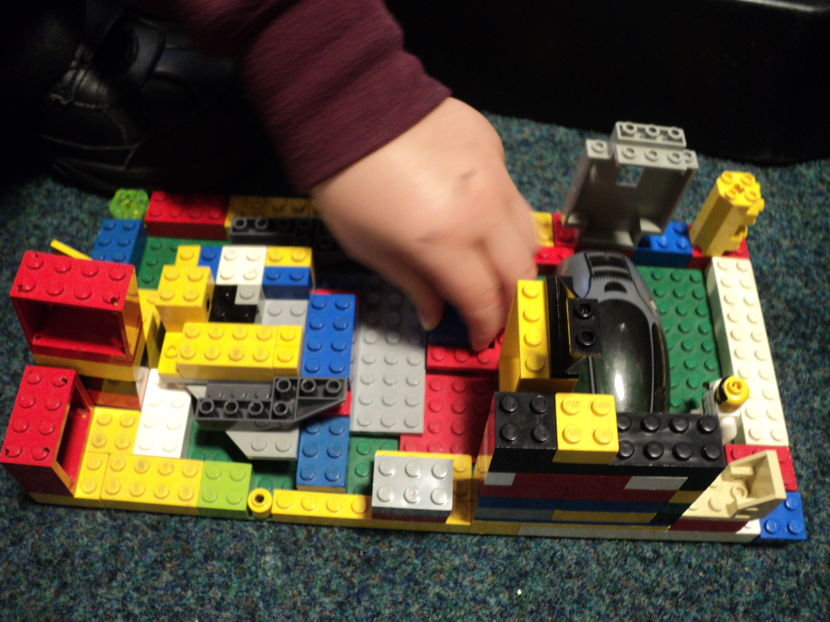
A Church
