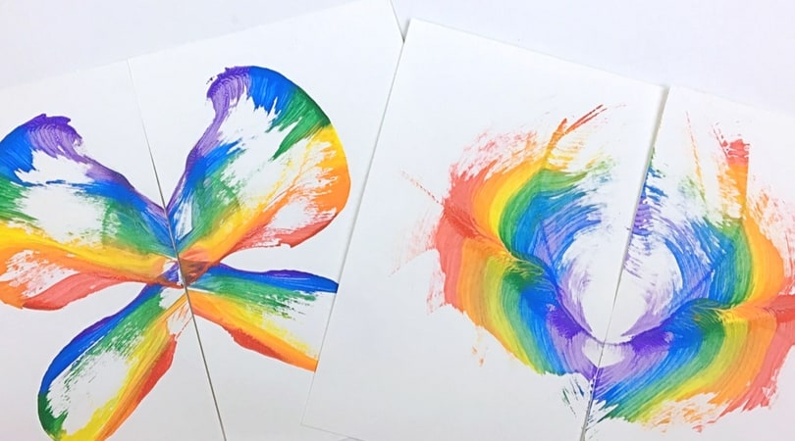

**Painting Worm Patterns.**

Use your ‘Superworm’ skills to make a picture with string that has been dipped in paint. Try wriggling and moving the string around the paper just like a worm moves through soil. Why not experiment with different colours. Try making a symmetrical picture by folding your paper in half.

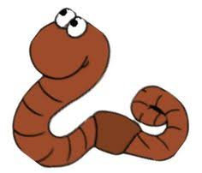

**Worm Rain Dance.**

6 stomps - one foot 10 stomps – other foot 6 claps 5 bunny hops 2 spins 4 times

Shout “Rain!”

**Rain Dance.**

Worms come to the surface when they hear the rain on the ground. Sometimes noises convince them it’s raining and to come out. Can you make your own rain dance to make the worms appear? Think about how you could make the worms in your garden think it is raining.

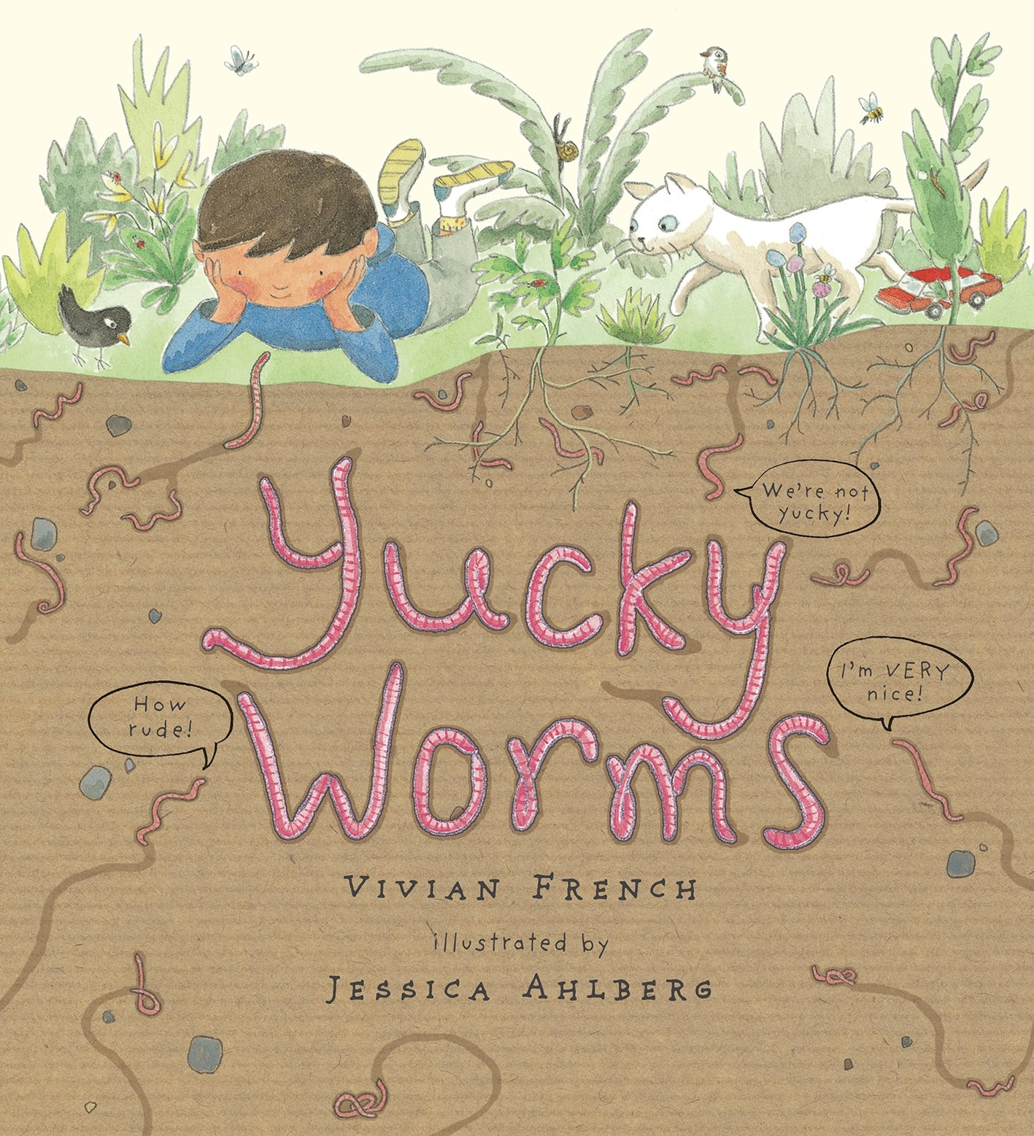

**Worm Hunting**.

Follow the instructions on how to be a ‘Wormologist’. Go on a worm hunt in your garden. When you find a worm think about what you know. Is your worm a young worm or an adult worm? Can you find any worm casts? Can you tell your adult something special about worms? Where do they like to live? How many hearts do they have?

**Superworm.**

Listen to Mrs Scott read the story of Superworm by Julia Donaldson

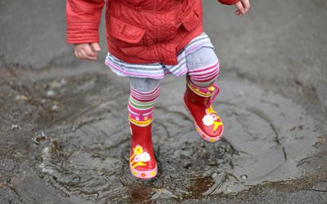

**I Can Only Draw Worms.**

Listen to Mrs Waller read ‘I Can Only Draw Worms’ by Will Mabitt and join in drawing.

**Yucky Worms!**

Listen to Mrs Mason read the story of Yucky Worms by Vivian French

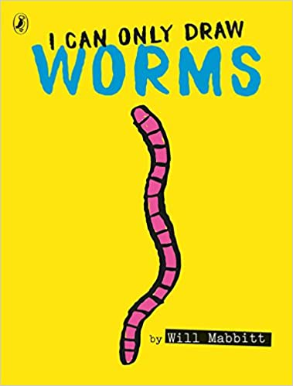

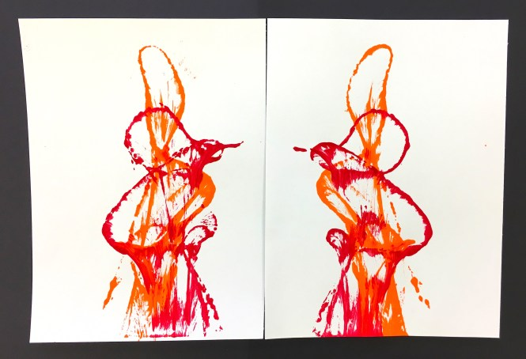

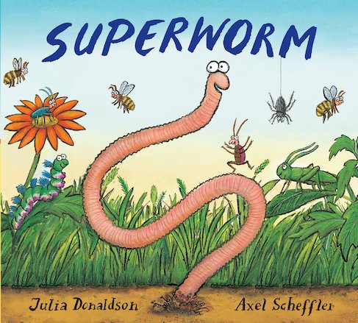

**Superworm Moves!**

Superworm has many abilities and lots of moves. How many super moves can you do in one minute? Ask a grownup to time you. Superworm the skipping rope. How many skips can you do in one minute? How many hula hoops can you do in one minute?

Home Learning Ideas

Week beginning:

29th June 2020

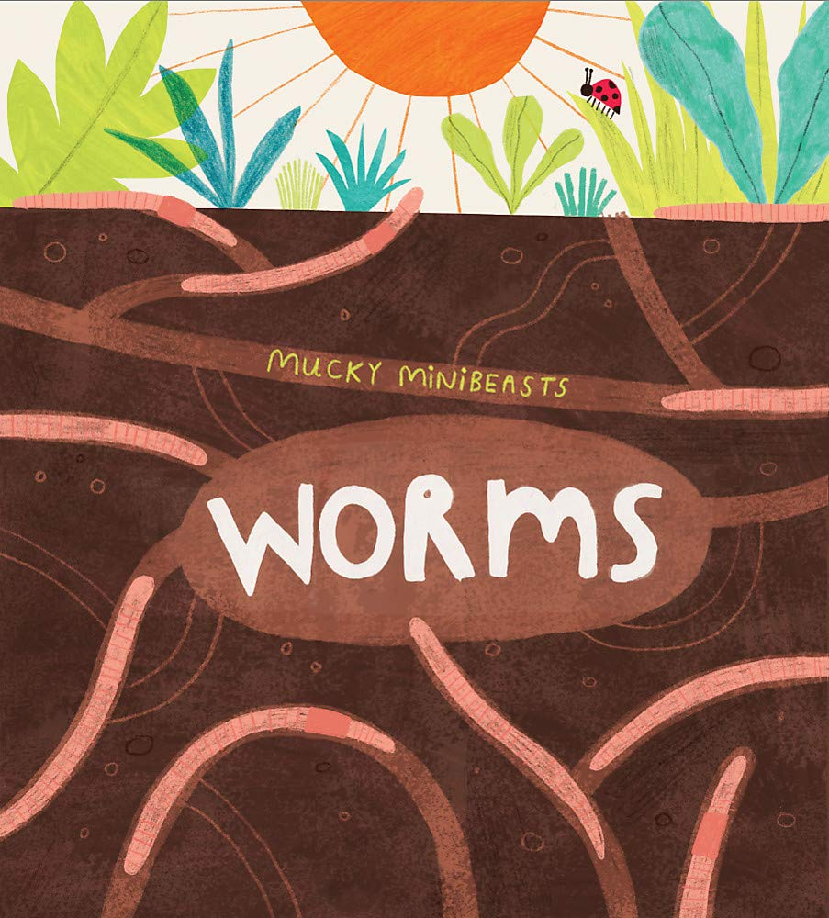

**Worm Facts.**

What do you know about worms? Find out all about worms with Mrs Mason.

**Worm Race.**

Play the worm race with your family. A game to make the longest worm!