The Three Little Pigs.

We’ve been retelling the story of The Three Little Pigs through story maps, role-play, small world figures and puppets. This is an excellent opportunity to develop and consolidate the use of another style of story language, repetition and evoke some more extended pieces of writing. Next week we are looking forward to innovating the end of the story with different versions of what happened to that Big Bad Wolf.

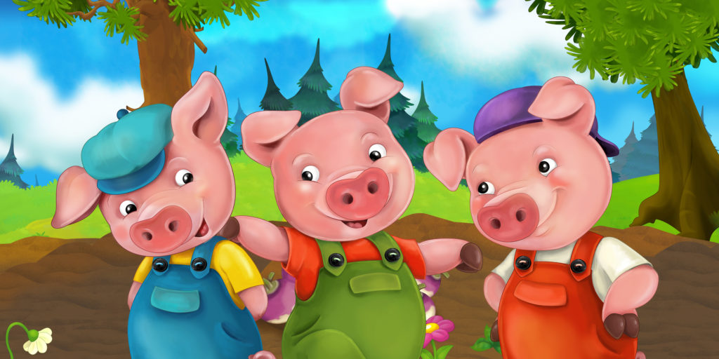

More Money!

In numeracy we’ve been finding different ways to make values e.g. sorting coins to find ways of making 4p, 5p, 6p, 7p, 8p. To consolidate this learning, how about playing shops at home and using coins to find values.

Have a super weekend!

The Reception Team.

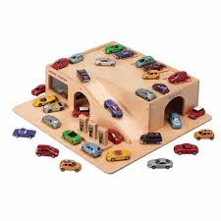

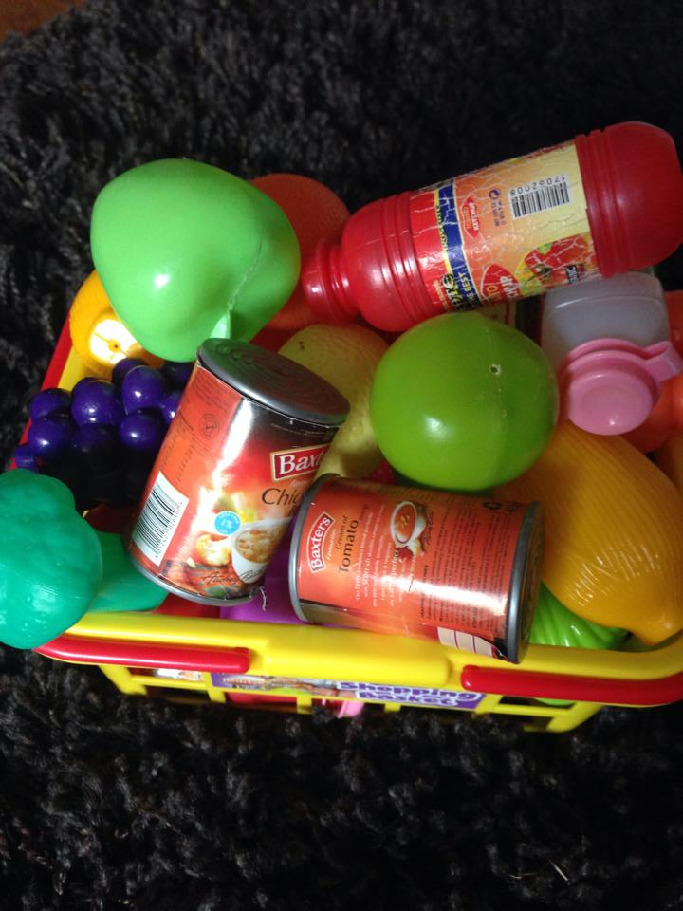



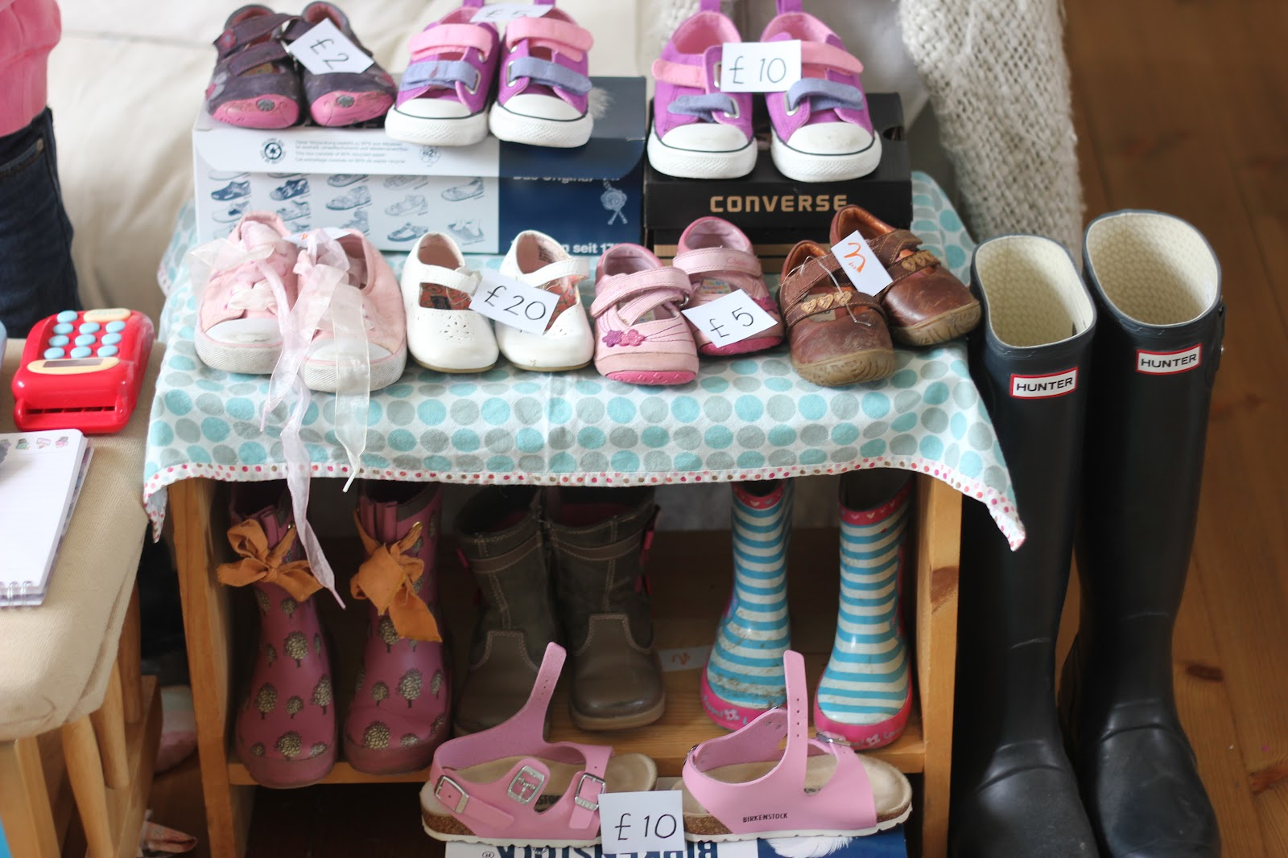

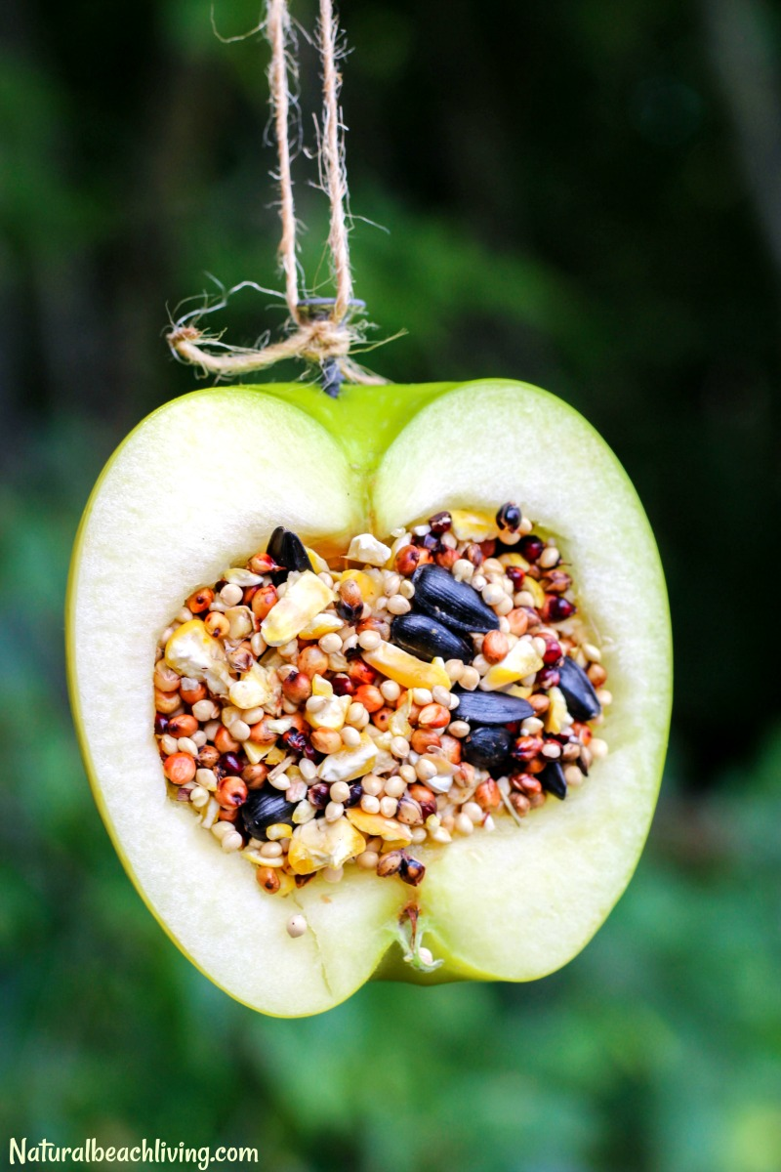

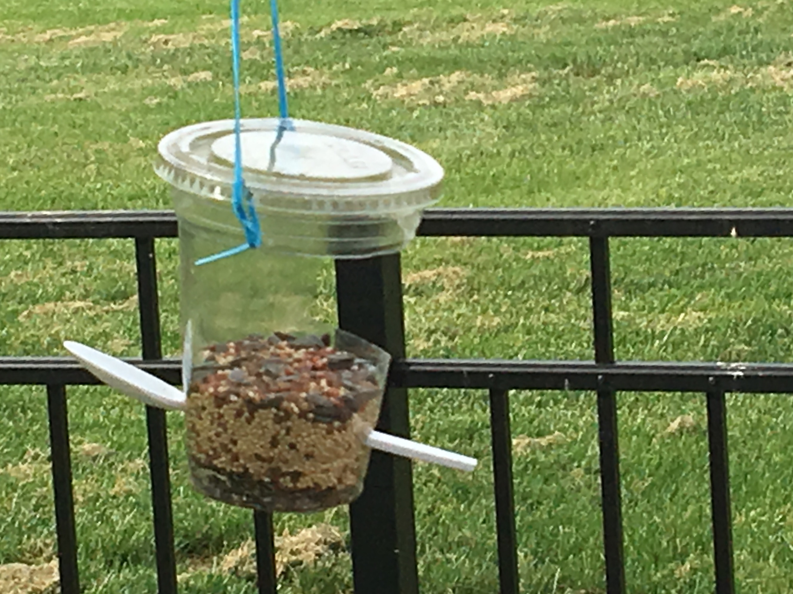

Birdwatch.

A big thank you to those of you who managed to do some bird watching last weekend especially because the weather was so nasty. Your input helped get us off to a really good start to our topic this week.

We’ve learnt some super facts about Blue tits. Did you know Blue tits are very neat and tidy and have been known to use lavender, mint and curry plants as disinfectant! We have these plants in our classrooms and we have been smelling them and using adjectives to describe them.

Perhaps you and your child could do some research this weekend and find some more bird facts to share in school.

Making birdfeeders at school has been lots of fun and we hope you enjoy hanging them at home. Maybe you and your child would like to check out the cbeebies website which has some lovely ideas for making bird feeders at home. www.bbc.co.uk/cbeebies/makes/bird-feeder

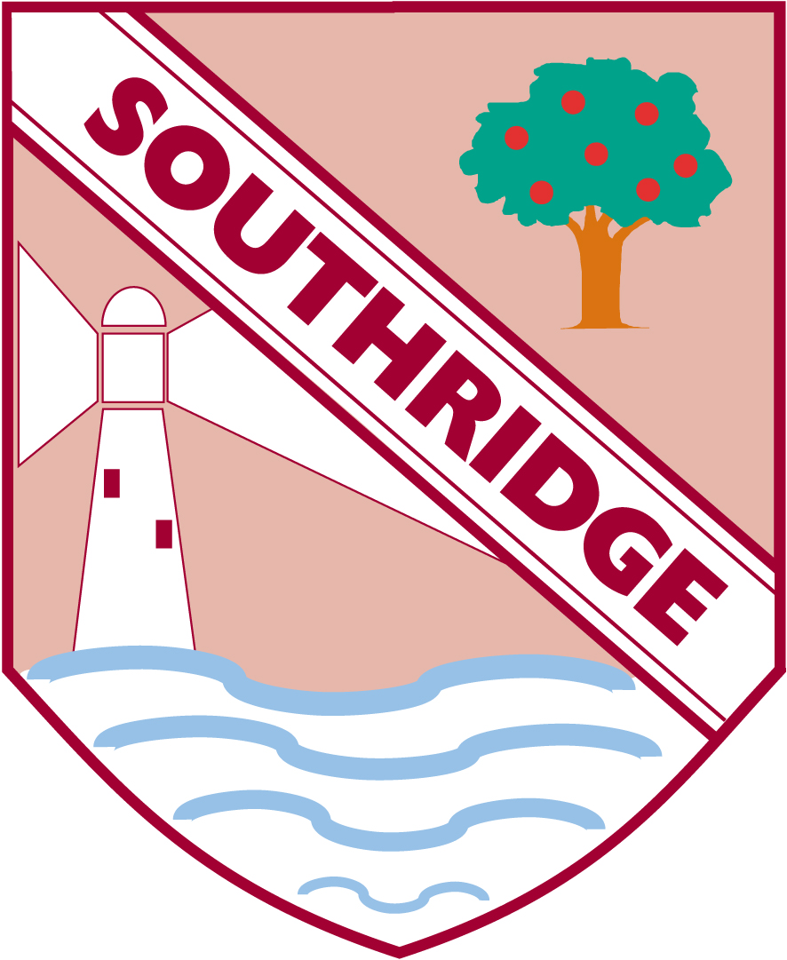

Southridge First School Reception Newsletter 2.2.19