Day | Phonics | Maths Focus | Lunch | Story time | Being imaginative
Monday | Geraldine giraffe letter ay  https://www.youtube.com/watch?v=MTCP8i4Nwgc  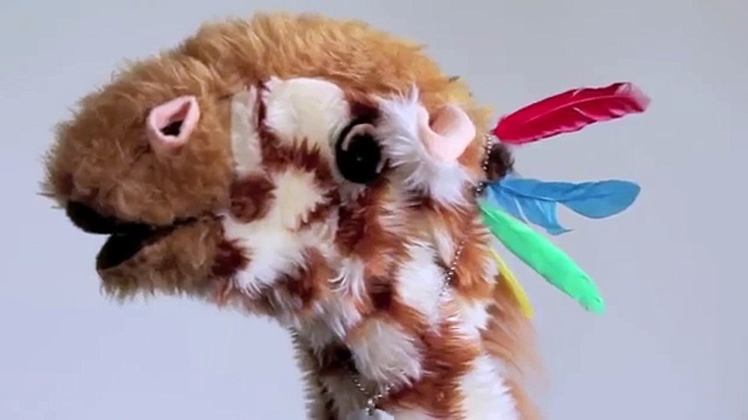 | Count forwards and backwards to 20  Google songs to aid this.  Arrange numbers to 20 in the right order. E,g make your own number line. Now count on you own number line. Repeat this with funny voices. | Make some toast for lunch and use a knife safely to cut it in half. What shape do you get? Now cut it in half again, how does the shape change? | ‘The ‘Nowhere Box’  https://www.youtube.com/watch?v=jz4Obw4YMqU  ( see resource) | What could you turn a box into?  ( see writing resource )  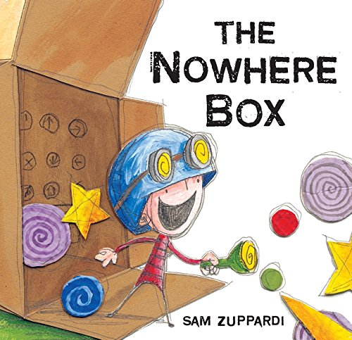
Tuesday | Geraldine giraffe ee sound to recall last week’s new digraph.  https://www.youtube.com/watch?v=qfM7Hz7US0U | https://www.topmarks.co.uk/learning-to-count/chopper-squad  Find one more and one less.  Use the number line you made yesterday to help you. | Freeze juice into box shapes for your lunch time drinks. How many faces does a cube have? | See ‘The adventures of a box film on youtube.  https://www.youtube.com/watch?v=XnbhLwNUQ-Y | Use different sized boxes to make whatever you want. Send us your pictures designs and photos by email or post.
Wednesday | Geraldine Giraffe igh  https://www.youtube.com/watch?v=OYCR2RZ4ZYY | Your child is the teacher for this activity and you (the adult) have done some additions.  Cut and stick the number sentences in to right and wrong answers. (See resource). | Vegan Cube Tray Bakes.  https://www.bbcgoodfood.com/recipes/vegan-chocolate-party-traybake  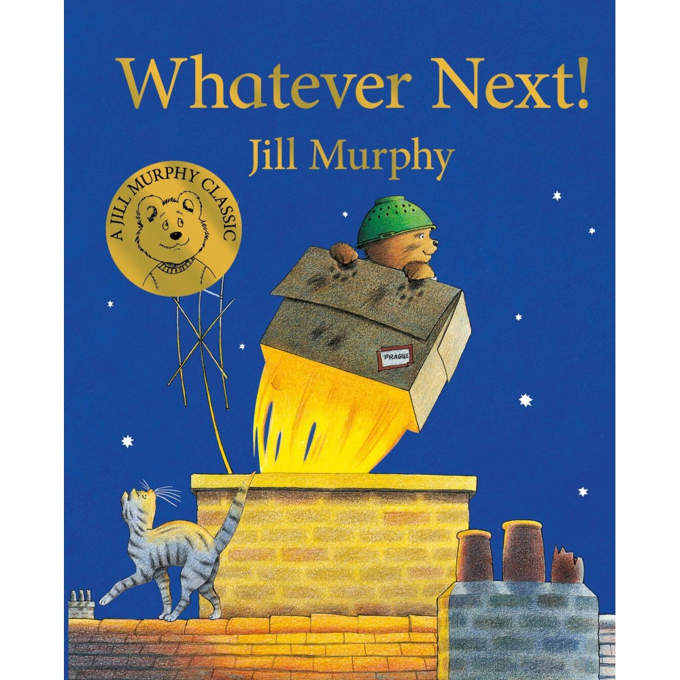 | ‘It’s not a Box ‘  By A Portis  You can view online via YouTube | Handwriting focus is ‘long ladder letters  Draw pictures of things beginning with the letter sounds you have been practising in handwriting today. How many things can you draw for each?  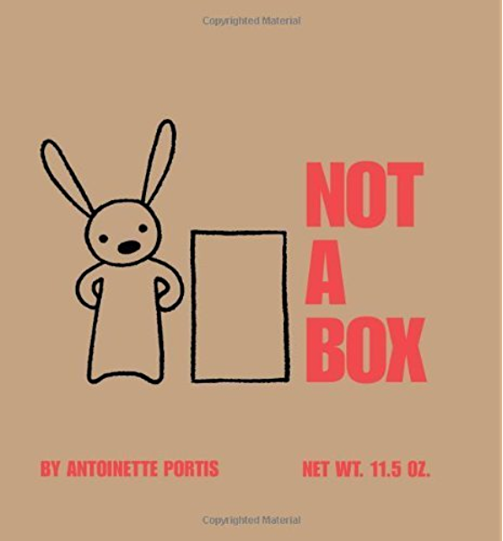
Thursday | Ow  Reading activity on web | One more one less game.  ( see resource) | Design and make a lunch box. | ‘Whatever Next’ | Can you google some famous cities around the world  Make a city with boxes? What is a city and
Friday | ‘Oo’  Reading activity on web | One less game to play in pairs. Who will cover all their dice numbers first ?  (See resource) | Make lunch in the home made lunch box you made yesterday. | Choose your favourite story to share. | RSPB Birdwatch.  Research on line with RSPB web site and make a birdfeeder.  Send us a picture then one if you see any birds.
The above is an indication of the direct teaching that we will be doing in school.

In addition our days are always full of ‘project work’. This is when children are given an opportunity to engage in open ended practical based opportunities. These include :

Whatever you want to be Role Play. (An area with dressing up, hats, wigs, some items of jewellery, pots pans etc.)
In this area children invent their own role play from doctors, home play, police and superheroes. Sometimes we rotate the resources around to allow for their interests.

Art materials to access freely? (Clay, paint, pens, stamps, cut and stick materials and recycled boxes and pots).

Block Play. (An excellent activity to enhance creativity, imagination, problem solving and skills which support what you may see as more academic subjects).

Small world Play. (A chance to retell stories and invent them an important prequel to writing extended pieces further up in the school).

Independent play is vital for young children. Play allows children to use their creativity while developing their imagination, dexterity, and physical, cognitive, and emotional strength. Play is important to healthy brain development. It is through play that children at a very early age engage and interact in the world around them.

