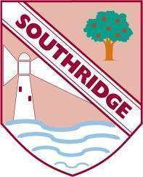
Southridge First School – Remote Learning Schedule

Our school core values are: Friendship, Kindness, Honesty, Respect and Responsibility

Date: : Thursday 22nd October
Year Group / Class: Reception TP
Today’s activities:

Below are your activities for you to complete today. The lessons can be completed in any order.
Overview for children:
Good morning everyone. Did you put your teacher hat on yesterday? I hope your family were impressed how good you are at being a teacher when I am not there.
Parents and carers:
All of the tasks below will be posted on the school website – Home Learning / Reception.
If you have any queries please do not hesitate to contact me
Kind regards
Miss Parker
tanya.parker@ntlp.org.uk

Maths in a Muddle:
This week we planned to develop children’s counting and ordering of number
Tasks :
- Continue to access ‘EYFS counting and ordering numbers to 20’ from the ‘Reception Home Learning Pack’.
New
- Counting forwards and backwards song . https://www.youtube.com/watch?v=ShqXL-zfLxY
- For those who enjoy a trickier challenge try working out to 100 forwards and backwards!!
https://www.youtube.com/watch?v=YtNskltyA0E&list=PLQK2XiUY9C2hQwPHTnfeisJymlRTJY_Vb&index=48&t=0s

Activity :
Go to Top Marks https://www.topmarks.co.uk/ordering-and-sequencing/caterpillar-ordering the numbers are in a muddle!!!
Choose the level of number that is most appropriate for your child to begin so they feel successful and then challenge them further as required. They love this interactive game and could make a different kind of game once they have completed the ‘Halloween House Sequencing Activity’. (Perhaps a bit like snakes and ladders? Or colour certain numbers to mean steps back or forwards.)
Dice games are always a good way of introducing counting forwards and backwards so play those games at home too.
Challenge to help greater depth thinking:
Counting and ordering past 10
Pronouncing ‘teen’ rather than ‘ty’ when counting
Counting on with counters in games such as snakes and ladders accurately

What to email to Miss Parker:
Email me on word document or pdf if possible a set of pictures and comments about how they got on. If this is not possible just send me an email with a brief description of what you did together and how you got on.

Reading Races and Rhymes :
Rhyme rhythm and beat are important prequels to spelling
Tasks:
- Continue tricky word ideas from yesterday

- Listen and join in with BBC rhymes https://www.bbc.co.uk/teach/school-radio/nursery-rhymes-songs-index/zhwdgwx ( dance, stamp, tap or clap out the rhythms whilst you watch)
- complete the activity ‘phase 2 phonics rhyming string cards’ from the ‘Home Learning Pack ‘ ( there are a few so just do as many as you feel is appropriate and then save the rest for a rainy day ) .
- Clap, tap or stamp a pattern of beats after your mum or dad or to your favourite songs.

Challenge:
I can invent an alternative ending to a familiar rhyme on my own with some support.
e.g twinkle twinkle chocolate bar ………………

What to email to Miss Parker:
There is no need to email me any photographs but I would love you to tell me how you got on spotting the rhyming words or making up a rhyme of your own.

PSHE:

Make a den from an old sheet in your bedroom so you can have your own quiet space. Show mum and dad how to do peer massage as a way of helping to relax. Put in it some of your favourite stories, some fairy lights or special friends. You could also practise your breathing techniques by putting your teddy gently on your tummy and watching it rise and fall as you breathe in for the count of four and out for the count of five.

Below is a picture of my bedroom den and my special friend.

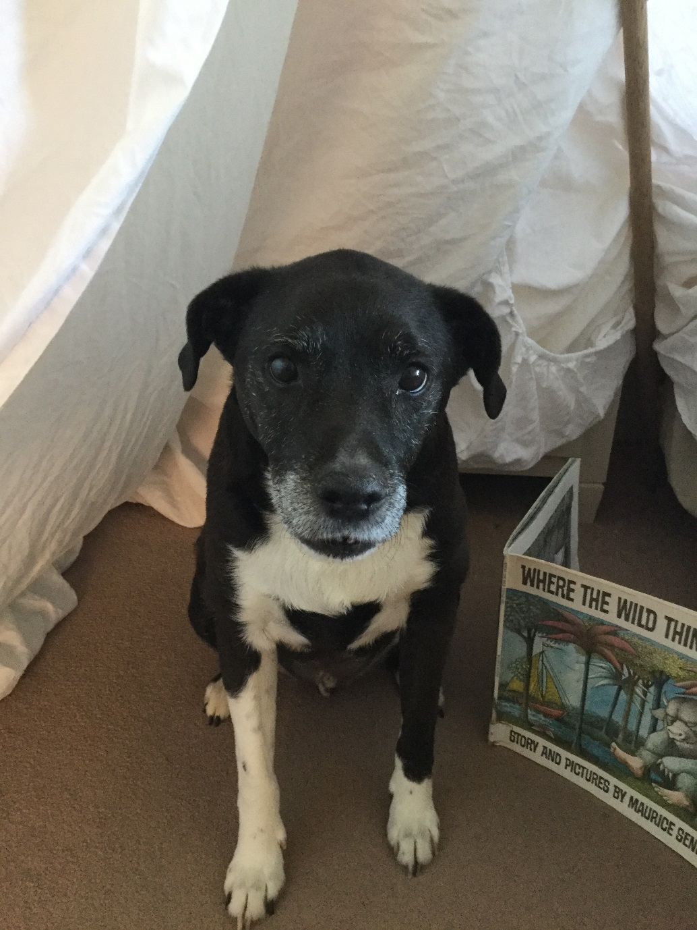
Your favourite books and special friends
A broom handle, poles from a wind break or canes
One large sheet.

