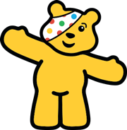

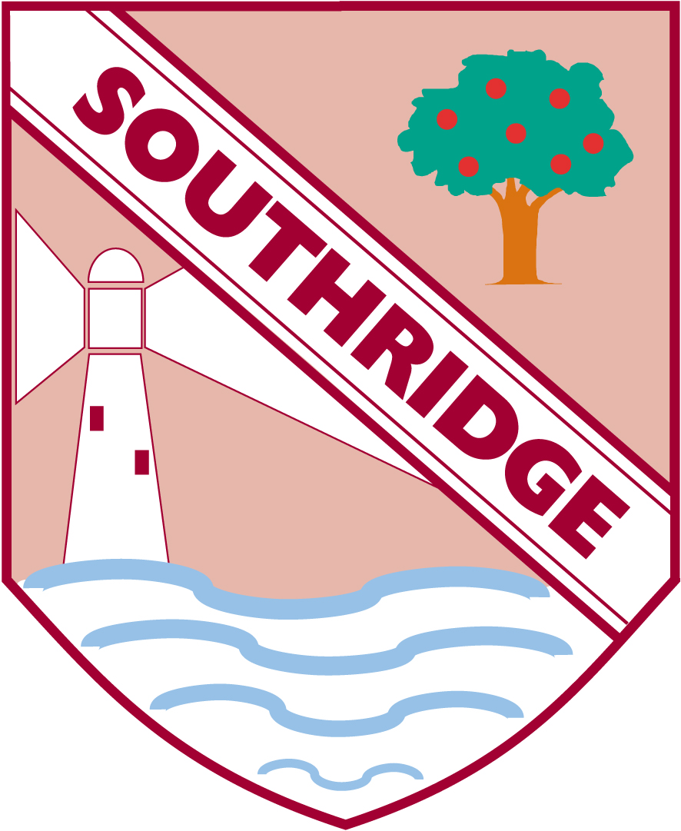

Southridge First School 9.11.19

We have had an exciting week responding to some very significant festivals this Autumn, Halloween and Bonfire Night.

Outdoors we have had some very messy but fun play mixing potions and spells.

We have been putting on a fire work display in our outdoor theatre using musical instruments as the noises we remember. We love the BANGS!!!! Cymbals were great for outdoors!

We have made large firework pictures using spray paints and washing up brushes to create different effects.

**Children In Need** Your child has been told they can wear odd socks for school on **Monday** this is being promoted by one of the CBeebies presenters - Andy. No donation is required for this.

**Friday 16.11.18** Children can come in Sports kit, fancy dress or wear something spotty. PE bags will be sent home on Thursday night so that children can come to school in trainers for our 'Sportathon Challenge'.

Next week our focus is the area of learning People and Communities. From learning about festivals such as Diwali, different kinds of families and ending the week with Children in Need and building awareness of children who may be less fortunate than ourselves.

**What Halloween or Bonfire Night creations have you made at home? Send us your pictures or observations.**





