Give your child a small selection of measuring equipment and quote what they say they think the equipment is for. (Three items is enough such as a measuring jug, tape measure or clock)
Remember to write down exactly what they say and not what you have given them as a tip even if it is not quite right. This is useful to us in knowing what language we still need to develop in our direct teaching but also great for assessment. Remember the child’s voice is the most important.
Record the quotes about the three items below and if your child wants to they can draw the equipment too.

Both classes will be visiting St Mary’s Church on 6th December. Miss Parker’s class will visit in the morning and Mrs Mason’s class in the afternoon. We need adult support to walk to and from the church. If you are available to help please let a member of staff know. Thank you.

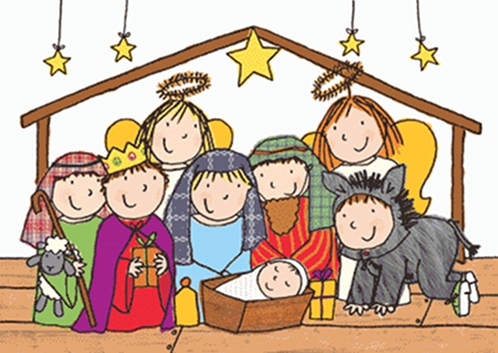
Christmas Performance. Remember to sign the form (at the Reception entrance door) for which Christmas performance you would like to attend on the 14th December at 9.30 am or 2 pm. Due to hall space, only two adults per child please and you can only attend ONE performance.

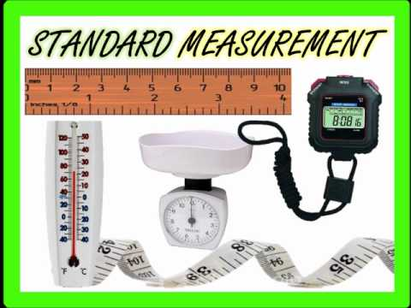
In mathematics this week and next our focus is the area ‘Shape Space and Measure.’
The Early learning goal we are working towards is very broad in this area it states that children should be able to:
“Use everyday language to talk about size, weight, capacity, position, distance, time and money to compare quantities and objects and to solve problems. They recognise, create and describe patterns. They explore characteristics of everyday objects and shapes and use mathematical language to describe them “
With this in mind we have attached some ideas about how this can be captured at home but over the next few weeks if children are counting down to a birthday or the weekend its events these may give us some great additional quotes, so bear this in mind.
See attached for this week’s focus on measurement.

Reception Newsletter 23.11.18
Shape space and measures fitness activity:
How many jumps can you do in a minute? Predict and test or visit
https://www.nhs.uk/10-minute-shake-up/shake-ups#ei4dBRA6hsV8HMQP.97
For a 10 minute shake up to Disney inspired stories.
Tell us how you got on.

