1 2 3 4 5 6 7 8 9 10 11 12 13 14 15 16 17 18 19 20

As demonstrated in the workshop on Monday, count forwards and backwards to 20. If you use a number line, have some fun and use different voices. Enjoy!

**Thank you for those who attended the ‘Working as Partners with Parents Workshop’.**

*If you did not attend a pack of the information that was covered has been put in an envelope in your child’s book bag.*

The most useful Top Tips to remember are:

* When reading there are bouncy and stretchy sounds. (It’s not d-u but ddddddddd).
* There are words to sound talk which are known as green words and tricky words which are not phonetical that are red words. (These are learnt by sight and cannot be sounded out).
* When sending in contributions for learning journals. Always record the child’s voice and make the contributions things which the child has done by themselves and not adult led. Do not send us lots of photos just one, or three showing a sequence of development is enough.
* Look out for newsletters. They have the activities you may wish to support us with.
* In mathematics always count forwards as well as backwards equally to reinforce both adding and taking away.
* Never call the activities you do at home for us ‘homework’ and work out good times to lead your child into activities or purposeful play. We do not want to put them off!

**PLEASE COMPLETE OUR EVALUATION SHEET IN BOOK BAGS TO LET US KNOW IF THE WORKSHOP WAS USEFUL TO YOU AND FOR YOUR CHILD.** (This helps future planning)

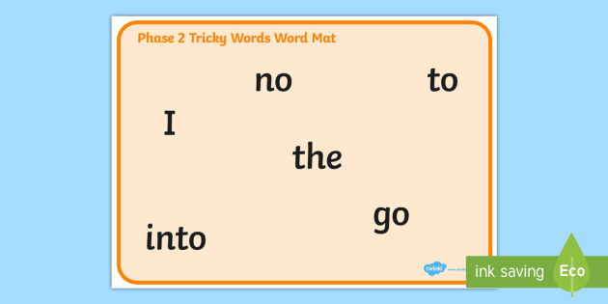

Look out for 5 tricky (‘red’) words to learn by sight in book bags. Take your time with these there’s no rush. Keep revisiting if you can and when you have time.

Keep collecting those large beach pebbles for our Pebble Pit. It’s looking good but nowhere near full.

Some of the pebbles will be painted and a lovely grandma from our Reception cohort is offering to share her painting stones hobby with us to help us to paint them ready for our ramble.

More help is needed so if you can? Please support us.

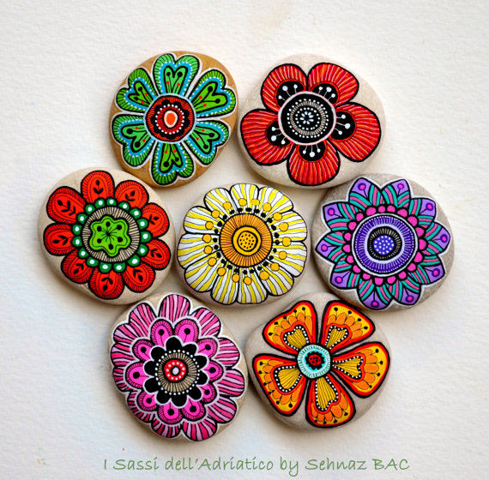



**Reception Newsletter: WB : 20.9.19**