Can you add speech marks to these sentences?

Hello, said the man.
____________________________________
What are you doing? said Fred.
____________________________________
Stop! shouted the policeman.
____________________________________
Wait a minute, said Mark. Don’t I know you from somewhere?
____________________________________
____________________________________
I know what we’ll do, said Lucy. We’ll go to the pictures.
____________________________________________________________________________

Can you improve these sentences using these punctuation marks – full stops, commas, question marks, exclamation marks and speech marks?
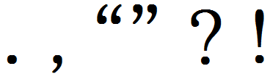

Bye said Greg
____________________________________

Can I come in asked the man
____________________________________

No screamed the man
____________________________________

Is that my bag asked Daniel I thought I’d lost it
____________________________________

Run shouted Sally The dog is after us
____________________________________

