

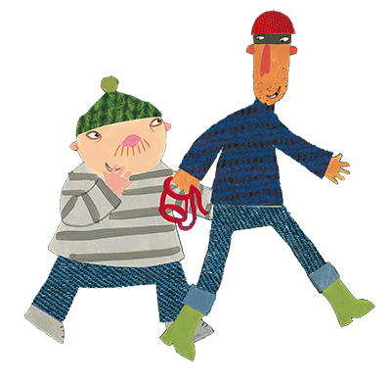

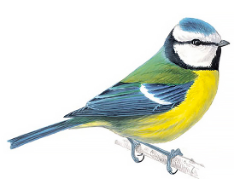

**Listening Game** –The Ladybird in the story hears everything! Encourage your child to tune into the sounds around them and play your own listening games saying ‘I hear with my little ear…’



**Sound of the Week** - Check out the Ruth Miskin parent video on YouTube – How to say the sounds. Help children to **hear and say g.** Talk about the sound it makes at the beginning of words like garden, goat, girl and glue.

**Nursery Rhyme of the Week** Old MacDonald had farm

**Draw a map of a familiar journey you take** e.g. to school or grandparents. Help your child to think carefully about the things they see on the way.

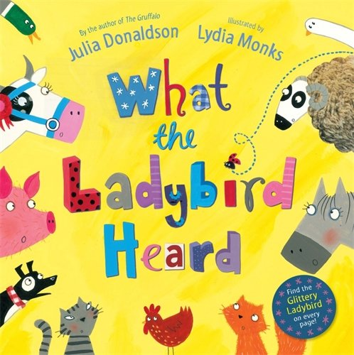

**Listen to ‘What the Ladybird Heard’** on the school website and discuss rhyming words.

**Make a poster to warn other farms about the robbers.**

Draw pictures of the robbers to show everyone what the robbers look like so they know who to look out for.

**Home Learning Ideas**

**Week beginning:**

**25th January 2021**

**Big Garden Bird Watch** - play your part in the world’s largest bird survey. Find out how - <https://www.rspb.org.uk/get-involved/activities/birdwatch/everything-you-need-to-know-about-big-garden-birdwatch/> Maybe you could make your own bird cake too - <https://www.rspb.org.uk/fun-and-learning/for-kids/games-and-activities/activities/make-a-speedy-bird-cake/>

**Early Maths Talk** – on the school website you will find a short PowerPoint of images that can be used as a starting point for talk about number. The dots and dinosaurs are grouped in very deliberate ways.

**Key Questions -** What can you see? Can you see any numbers? Does your child recognise groups of numbers without having to count them? How many dots/dinosaurs altogether? How do you know? You might like to note some of the things your child says about the images. Try revisiting the images later in the week.

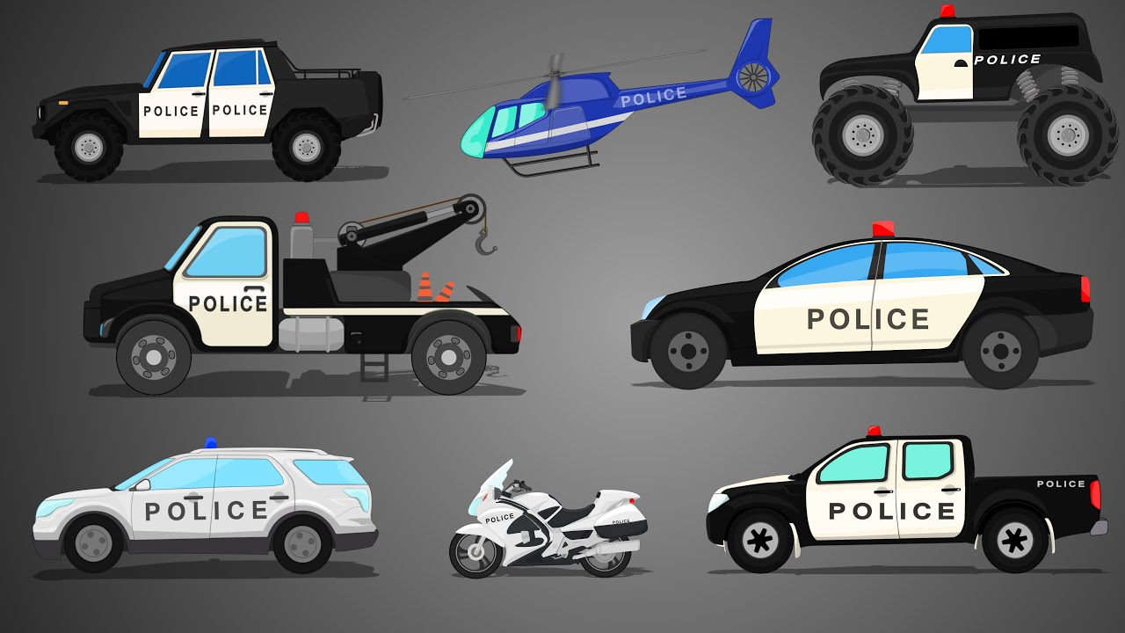

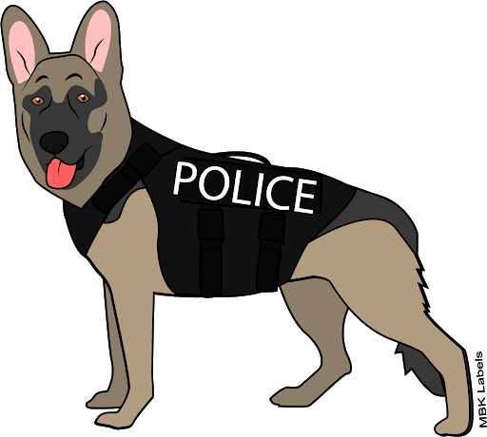

**Use the PowerPoint or research with grown-ups to find out about how police officers help us.**

What do police officers do to help us? What do they wear? How do they travel? What vehicles do they use? How could the police help you?

**Retell the story using puppets** - If you can, print off the puppets from the story and encourage children to help with cutting out and make into puppets using sticks or straws.