Measuring mass
This image shows that a bag of sugar weighs approximately 1 kilogram. Ask a grown up to let you feel a bag of sugar or something similar which weighs approximately 1kg.

Choose 2 items from your house e.g. a book and a pencil. Compare their mass by feeling how heavy they are. Practise saying the sentences:  “The _____ is heavier than the ________.”  “The _____ is lighter than the ________.”  If you would like a challenge you could try writing the sentences. | Look at the scales. You can print them out (they are attached on a separate sheet) or draw your own.  Choose 2 items from your house. Draw them onto the scales to show which is heavier or lighter.  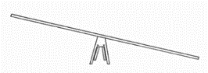  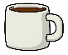  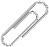  e.g. e.g. | Can you combine 2 items together to compare their mass? Draw them onto the scales or simply practise saying the sentences:  “The ____ and the ____ are heavier than the ____ and the ____.”  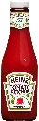  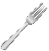  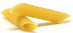  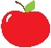  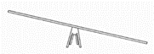  “The ____ and the ____ are lighter than the ____ and the ____.”
Can you find 2 items in your house that have a similar mass? Do they feel like they weigh about the same?  “The _____ is as heavy as the ______.”  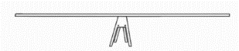  Can you draw them on the balanced scales? | 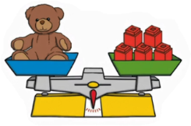  What can you tell me about the picture?  “The teddy bears weighs ______ cubes.”  “The weight of 5 cubes is the same as ____.” | What can you tell me about the picture?  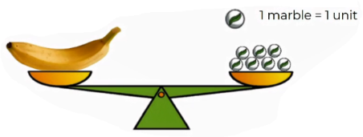  What do you think would happen to the balance if you took one of the marbles away?
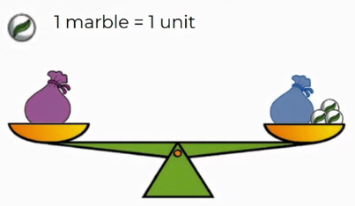  Challenge  Which bag is heavier? How do you know? Can you explain your answer to a grown up? | Investigate  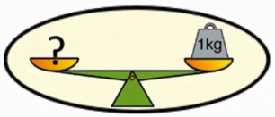  Now find items in your house that are:  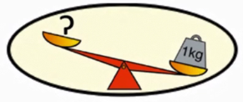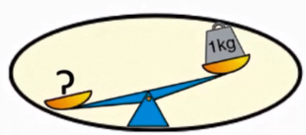  Lighter than 1kg Heavier than 1kg Equal to 1kg.

