

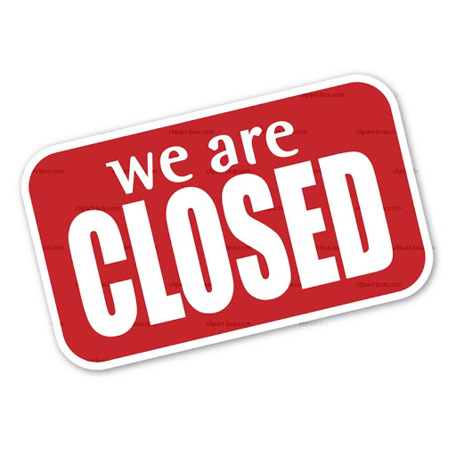

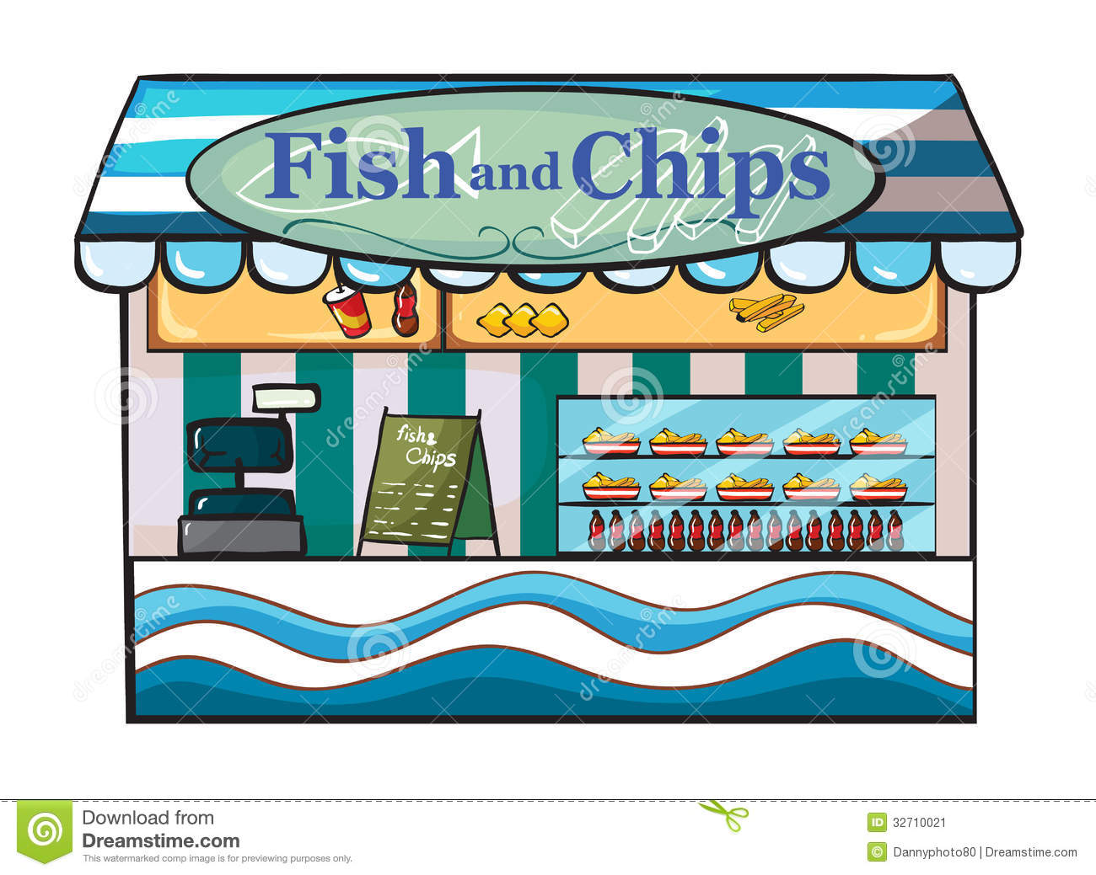

“I will get a **big** bag of chips”, said Tom.

“I will get a **big, big** bag of chips”, said Mitch.

Well, I will get a **big**, **big ,big** bag of chips!, said Patch.

NO! I will get a **big, big, big .big** bag of chips **and** a fish! , said Tess.

Cliff said, “ I will get a big big big big big bag of chips and 2 fish!.

No ! No! No! It is shut!

**Learn these red words before reading. (You may want to cut them up to play games with and practise).**

**he put of I you no the said we was**

***Before you start? Do you know the speed sounds and tricky words? I need to read this with confidence.***

**Speed digraph sounds to revise** :

ll ss ff tch ch sh th ng nk ay ee igh ow oo