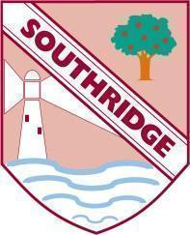
Southridge First School – Remote Learning Schedule

Our school core values are: Friendship, Kindness, Honesty, Respect and Responsibility

Date: First Day Response
Year Group / Class: Year 2
Today’s activities:

Below are your activities for you to complete today. The lessons can be completed in any order.
Overview:
Here are the details of our home learning activities for today.
If you have any problems then please do get in touch.
Kind regards
Miss McIntyre and Miss Smith
nicola.mcintyre@ntlp.org.uk linsey.smith@ntlp.org.uk
Maths:
- Complete a mental maths strip from: http://www.snappymaths.com/addsub/make20/resources/make20mmmab.pdf
- Data activities - Gather, read and record data in pictograms and tally charts and answer the questions.
- Times Tables Rockstars
English:
- Read the short text and answer the questions.4
- Adjective Encyclopedia - Using the books on your bookshelf, find one adjective for every letter of the alphabet
- Handwriting - Practising capital letters
- Spelling Shed
Music:
Follow the lesson https://classroom.thenational.academy/lessons/improvising-rhythms-65gkge
PE:
Pick one of the PE with Joe lessons PE With Joe - YouTube

