

**Reception Newsletter: 29.11.19**

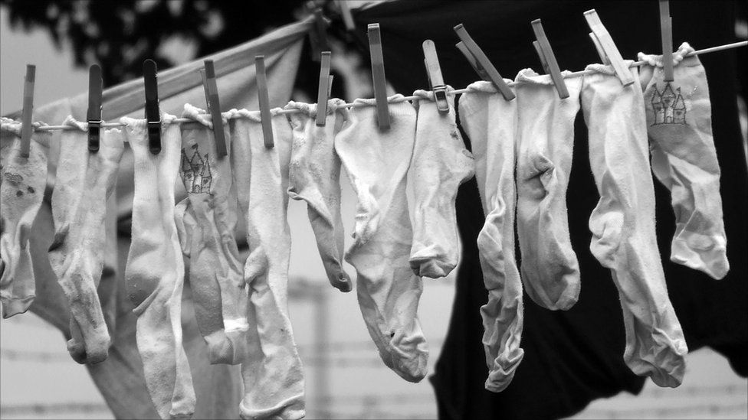

This week we have been extending their length knowledge through problem solving.

Children often enjoy finding matching pairs and pegging things up. Adults could provide a collection of socks of different sizes (including dolls, baby and adult socks, long socks and short socks) to sort into pairs. Set up a long washing line with pegs and a washing basket of different size socks, so children can find pairs and peg them up.

For this activity the focus is on size and length, rather than colour or pattern, providing opportunities for comparing and ordering. Include some odd socks. Encouraging mathematical thinking and reasoning:

Describing: Tell me about the socks you’ve found/sorted out/put on the line already. Why do you think those aren’t a pair? Where do you think these ones should go?

Reasoning: Have we got room for any more? Have we got enough pegs?

Is that the longest sock? Are you sure? Why do you think those don’t go there?

Please send us your quotes via email or on paper.

**The school Christmas Fayre is Friday 6th December**. Don’t forget to sell your raffle tickets and return them to the office or pass to a member of staff. **On the day please leave school bags at home.** Children can wear non-uniform, Christmas accessories, Christmas jumpers in exchange for a donation to the tombola / bottle stall. Donations can be sent in to the office in advance.

**December Friday 13th is our Christmas performance as well as Christmas jumper day.**

Can we ask you to dress them in a plain black t- shirt under their Christmas jumper.

The hall is too hot for jumpers and a black t shirt will be far more appropriate.

This is the only contribution we will be asking for as we have costumes and have been learning the words ourselves.

Just come along and join us for a magical and traditional nativity this year to really get you in the festive spirit.





For Enrichment Day we celebrated Thanksgiving.

Thursday is always Sunday Dinner Day, so it was just perfect for our celebrations.

Can you find a map of America? Where is it? Have you ever been?



We have had the draw for selecting the parents for the trip to the Northern Stage. If you have not already received notification of your place it will be with you shortly. There will be guidance for a short meeting to be held in the ICT suite in order to share the risk assessment, groups and agenda for the day.

The kitchen will provide a biscuit and children will be taking their water bottles with them.

