

We’ve been doing lots of counting this week, forwards, backwards, in 2s, 5s and 10s! To consolidate this learning at home you could -

* Check out YouTube where there are some fantastic songs you could use for counting in 2s, 5s and 10s.
* Sorting socks, shoes and gloves into pairs and counting in 2s.
* Counting fingers and toes in 5s or 10s.

This week we have been reading Stick Man by Julia Donaldson and noticing rhyming wor words. Why not look out for rhyming words together in your own book collection at home this weekend and let us know how you get on.

Faith and Diversity Day Next week we will be celebrating our British Values along with the Nursery children on a tour of Mrs Pringle’s Scottish heritage, Miss Parker’s Welsh heritage and Mrs Mason’s English heritage. The children will have the opportunity to experience each of these counties through a series of workshops.

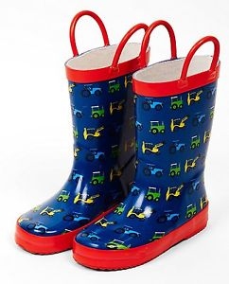

**Wellies!**

There is lots of fun and learning to be had in our outdoor area this term and it will often be wet out there. We provide puddle suits to protect uniforms and coats but can we ask that you ensure your child has **named wellies** left in school to use every day. Thank you.

**Happy New Year to you all.** We trust you all had a lovely Christmas, it has been wonderful to come back to school and hear the children talk about their families and tell us all about the festivities with such excitement.

We would like to say an enormous THANK YOU for all the kind presents and cards we received at the end of term. You were so very generous, thank you very much. Thank you for coming to see your talented children in our very special nativity and coming along to the Christmas Fair. Your support has been brilliant.

**Southridge First School Reception Newsletter 11.1.19**

