Home Learning Ideas
Week beginning:
4th January 2021
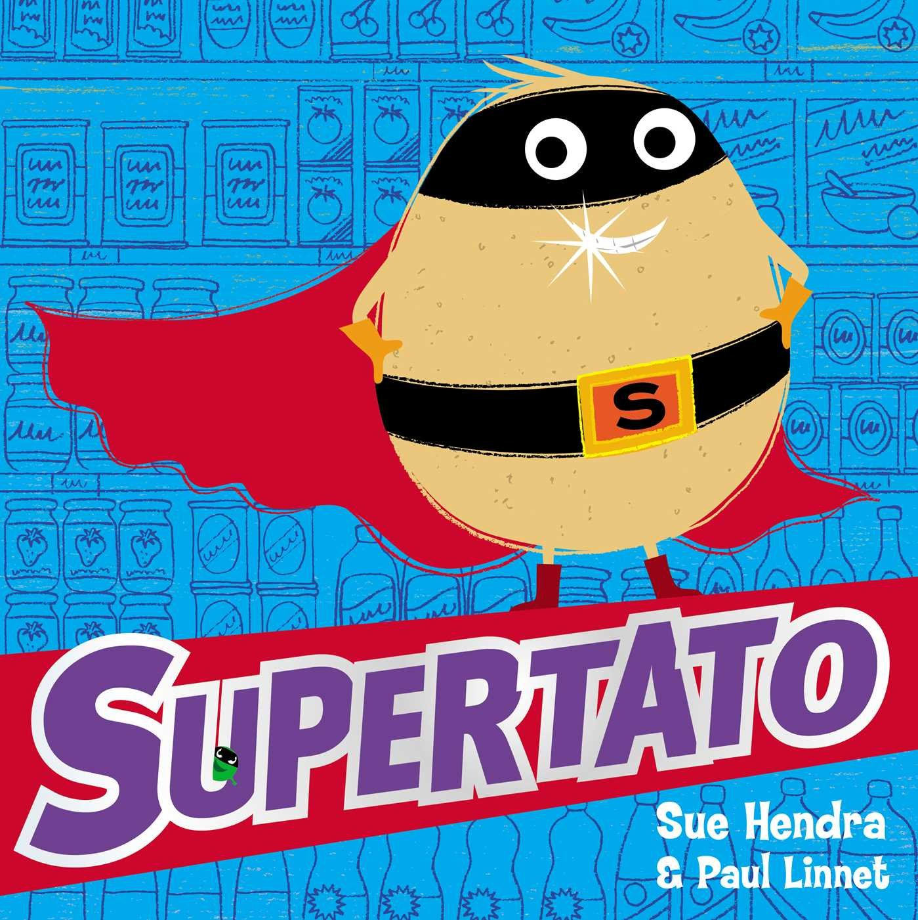
Listen to the story of Supertato on our school website.
This story offers lots of lovely opportunities for exploring vegetables.

Vegetable Hunt - This is Evil Pea. He has hidden 9 vegetables around your house. Can you find them? What kind of vegetables did you find?
Painting with Carrots - Can you use carrots as a paint brush to make marks? You could also try some potato printing. Encourage children to hold carrots correctly to try to write/draw.
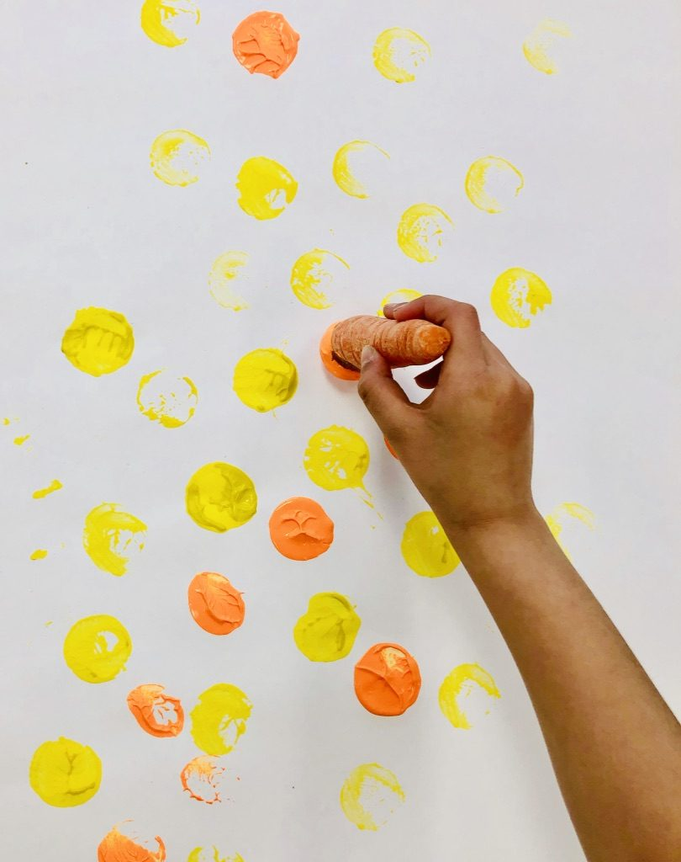
Careful Counting – explore the number 9. Line up 9 objects. Count them slowly and carefully by touching each object.
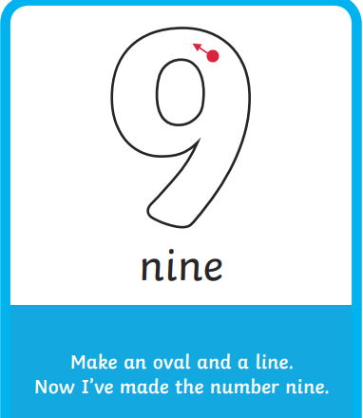
Make a Trap - Use junk materials or building blocks to make a trap to capture Evil Pea!
Reviewing Sounds - You might like to use this week to review the sounds we have learnt so far. They are:
m a s d t i
Check out the Ruth Miskin parent video on YouTube – How to say the sounds.
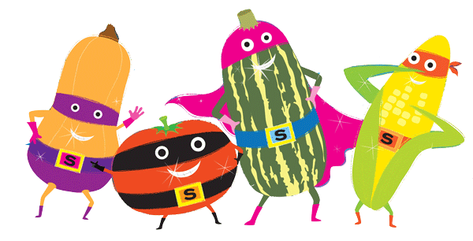
Keep a look out on the school website for additional home learning materials. Thanks for your support!

