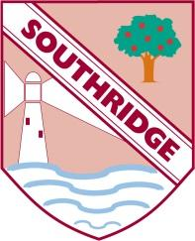
Southridge First School – Home Learning

Year Group : 3 Week beginning: 13.7.20

English: (For the week)
Reading:
- Please encourage your child to read every day –books from home.
- Encourage your child to read aloud and in their head.
- Ask your child questions about the text e.g. What do you think that word means? Can you think of another word you could use? How does the character feel? What do you think will happen next / can you think of another ending to the story?

English: (For the week)
Spelling: Summer 2 week 7- Please can you learn this week’s spellings.

Tasks: (Daily) Grammar
Monday- Synonyms
Tuesday- types of nouns
Wednesday and Thursday – creative writing
Friday- My favourite memories
English: (For the week)
Handwriting
Please copy out a passage from a book /poem in your best handwriting

Maths: (For the week)

Tasks: (Daily)
Monday –Maths three monkeys
Tuesday – Maths neighbours
Wednesday – addition and subtraction
Thursday– Time
Friday- coordinates
Foundation-
Monday- Science- How fossils are formed

Wednesday-PSHE- I am an amazing person

Friday- Geography- Pirate Coordinates

Please keep your work in a folder and hand it to your teacher when you return to school

(If you are unable to print from home please just write what you can on paper and return to school)

Helpful resources
Oak academy home learning
BBC Bitesize home learning
Top marks
Rockstar maths

