

Run! Run! As fast as you can!

You can’t catch me I’m the Gingerbread Man !

For our enrichment Day this week we are celebrating World Children’s Day. Do we have rules? Why do we need them? Can you think of ways we can protect children who may be in need? We found out about other children in the world and how their life may be different to ours

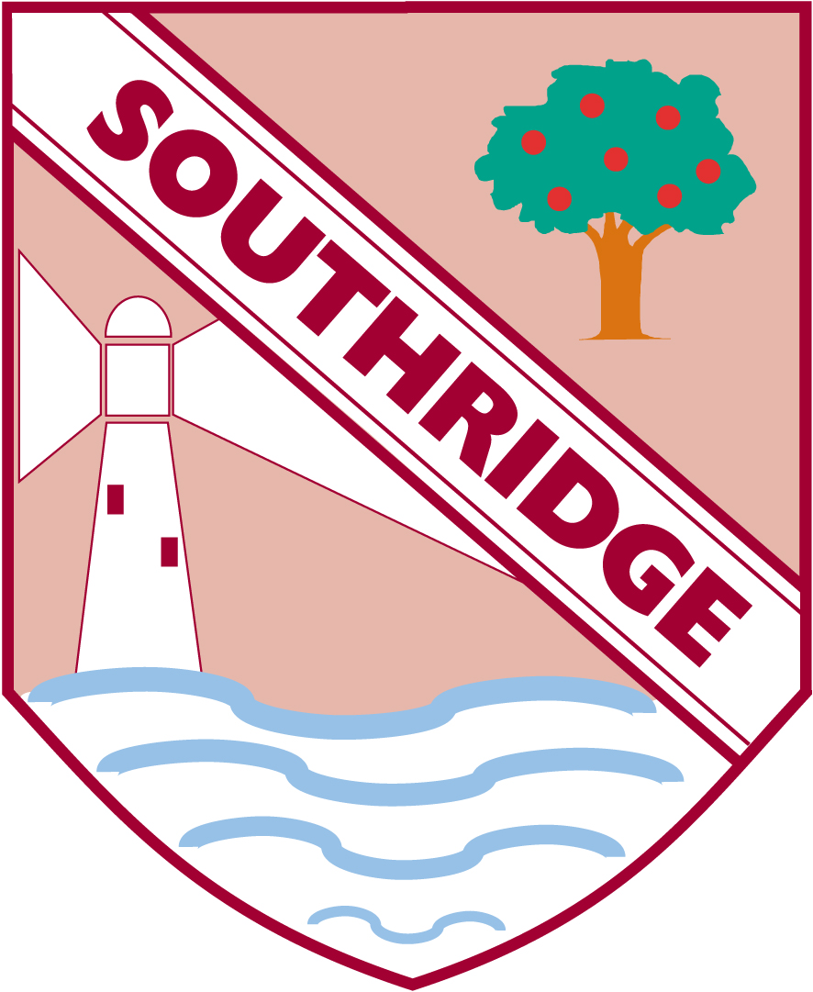

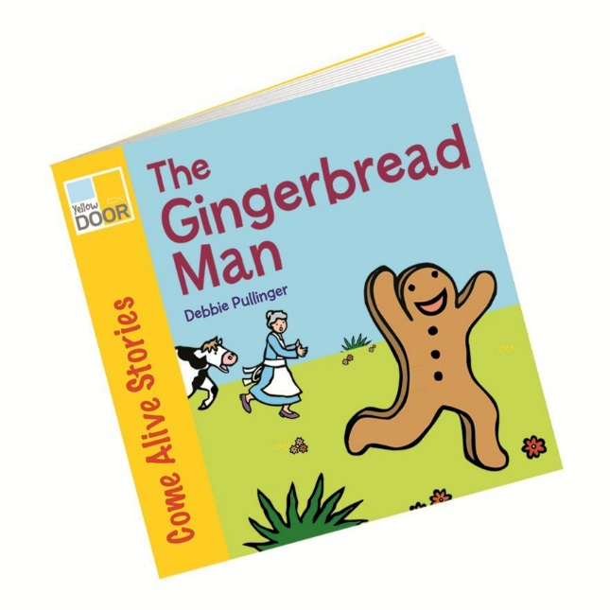

Please look out for this grip at home when your child is using pens or pencils. Bad habits develop quickly so we know you would like your messages to be consistent with ours. We hope you find this helpful

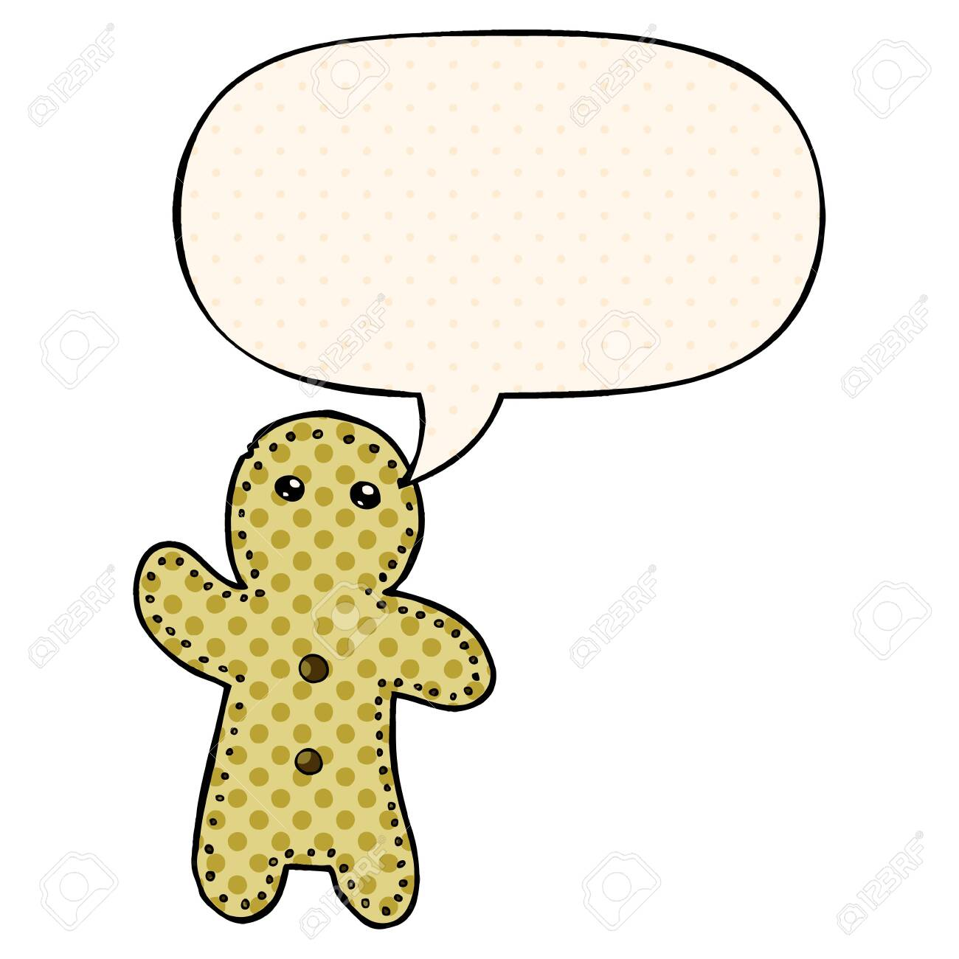

We showed the children a 30cm ruler. We looked around the classroom for something which was longer than this ruler and shorter. We recorded our investigation.

Outdoors we measured how far we could throw a bean bag with metre sticks.

**What can you measure at home this week? Send us your observations**

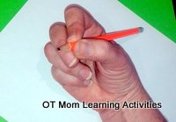

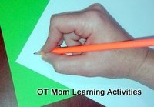

Work has begun, and will continue, with the most effective way to hold a pencil and thus write.

An **ideal pencil grip** is one which enables the child to

* Move the fingers (not the whole hand, the wrist or the arm) – controlling the pencil is more efficient with finger movements
* Complete a writing or drawing task without getting tired
* Complete a writing or drawing task neatly

Studies have shown that being able to use the small muscles of the hand and fingers plays a big role in a child’s handwriting, so it makes sense that the**pencil grip should allow those refined finger movements**.

An immature or poor pencil grip tends to block the finger movements, and the movements to form letters will come from the wrist and/or the arm instead.

Teachers have traditionally considered the correct pencil grasp to be the “**dynamic tripod**” grasp, where the thumb, index and middle fingers are holding the pencil.

When the **ring and little fingers** are tucked out of the way on the side of the hand, this forms an arch of the knuckles running from the index to the little fingers (the **distal transverse metacarpal arch**). The **DTM arch** is important as it gives stability to the joints and muscles of the hands while the tripod fingers are moving and thus reduces fatigue during handwriting. The fingers are able to move freely.

This half term’s Talk for Writing focus is The Gingerbread Man. This week we have enjoyed reading the story and joining in with the chanting ‘run, run as fast as you can’. We saw the appearance of an exclamation mark again (which if you remember we like to call a ‘shouting stick’)!

Teachers encourage the children to segment the sentence and use the tricky word ‘you’ in their writing.

**Reception Newsletter:18.11.19**