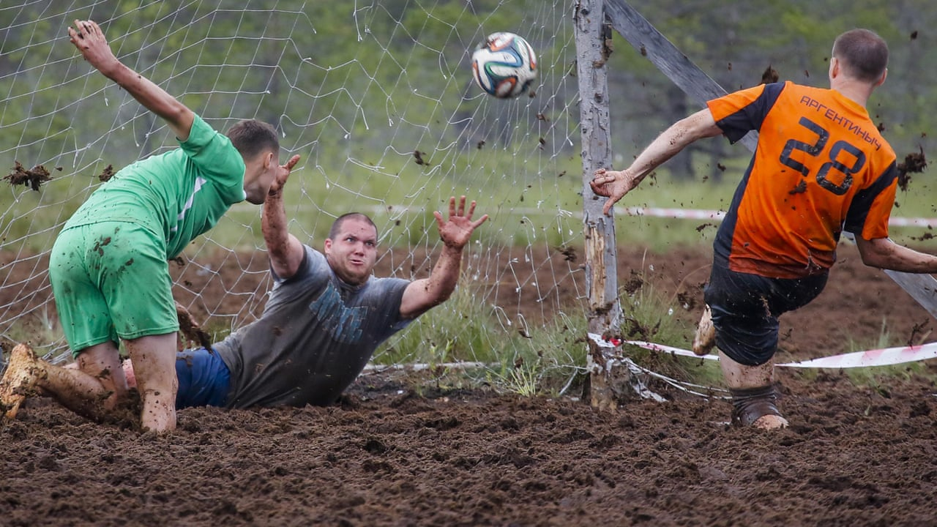

Mitch went to the match to play.

I was in the stand and I had a drink of pop.

It was wet and the pitch had mud on it.

“run! run! run!” We can win!

Splosh and splash went the mud.

Slip went Mitch!

“NO”! I said.

No win!

**Learn these red words before reading. (You may want to cut them up to play games with and practise).**

**he put of I you no the said was we**

***Before you start? Do you know the speed sounds and tricky words? I need to read this with confidence.***

**Speed digraph sounds to revise** :

ll ss ff tch ch sh th ng nk ay ee igh ow oo