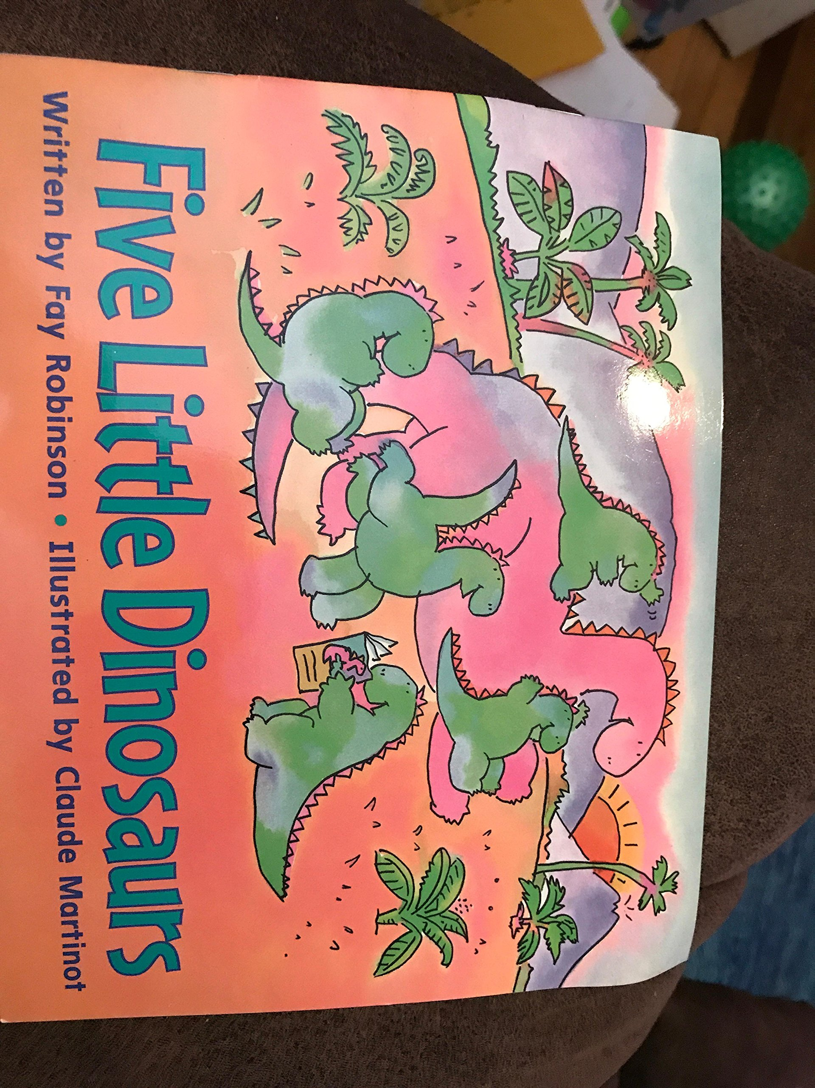

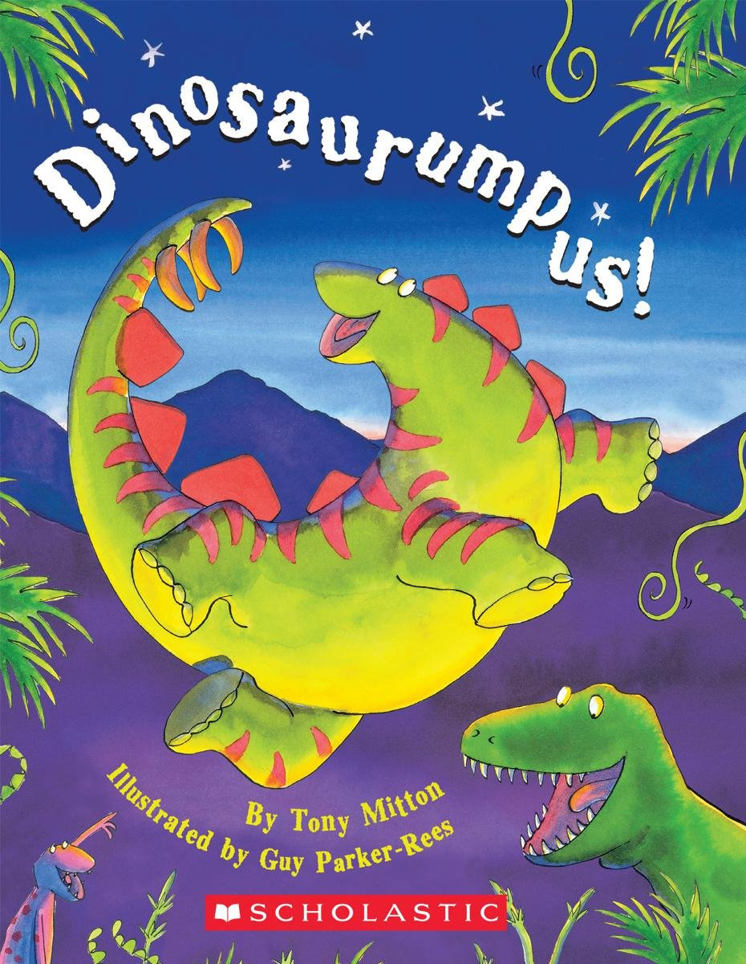

Listen to our Dinosaur Stories.

Bumpus Jumpus Dinsaurumpus! Dinosaurs Love Underpants! Five Little Dinosaurs!

Ordering numbers.

Can you cut out the numbers and then stick them in the correct order? Can you order 1 – 10 independently? Maybe you could try ordering 11 – 20.

Use the BBC Radio link below to join in and sing along to the Dinosaur Nursery rhyme?

<https://www.bbc.co.uk/teach/school-radio/nursery-rhymes-dinosaurs/zv7rf4j>

Dinosaur counting.

Count the dinosaurs carefully and write the number next to them.

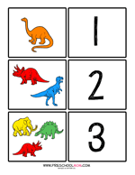

Number formation.

Practise writing numbers with the dinosaurs. Remember to use your birdie beak pencil grip.

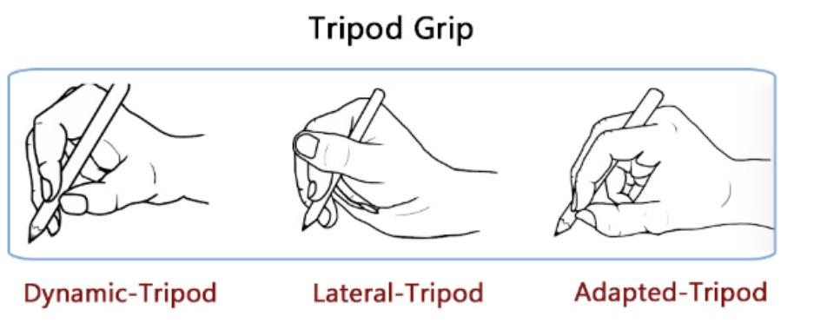

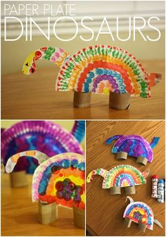

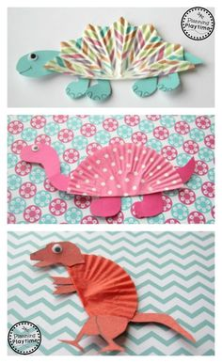

Tricky Dinosaur Cutting Challenge.

Practise your cutting skills by carefully cutting along the dotted lines then stop when you get to the dinosaur.

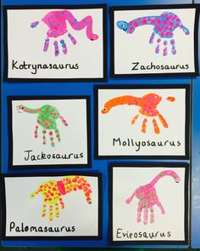

Design a Dinosaur.

Why not design your own dinosaur. What would you call your dinosaur? What kind of adventures would your dinosaur go on?

Home Learning Ideas

Week beginning:

22nd June 2020

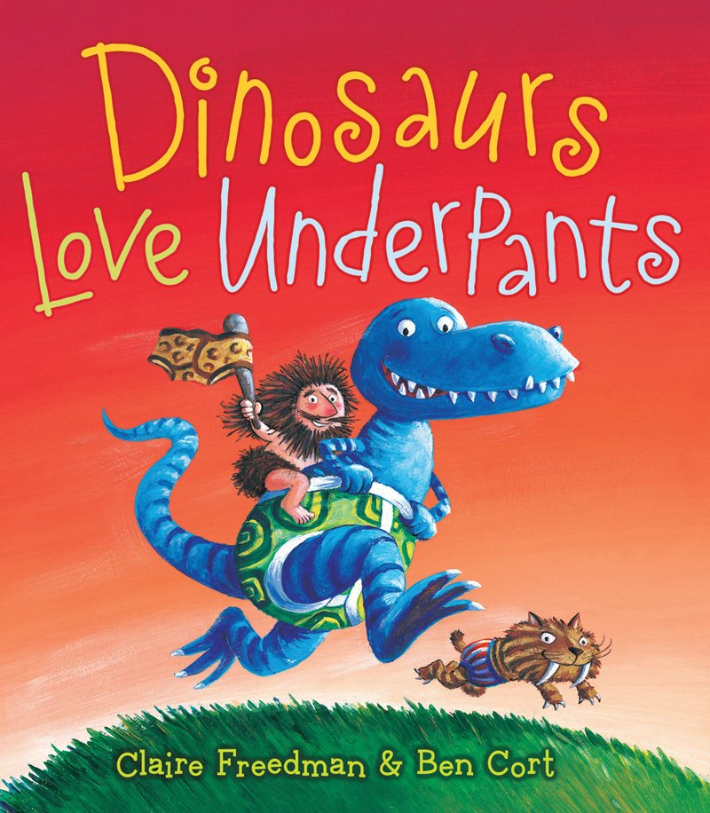

Tricky pencil control maze.

Follow the path from one dinosaur to the other. Try to stay in the middle of the path.