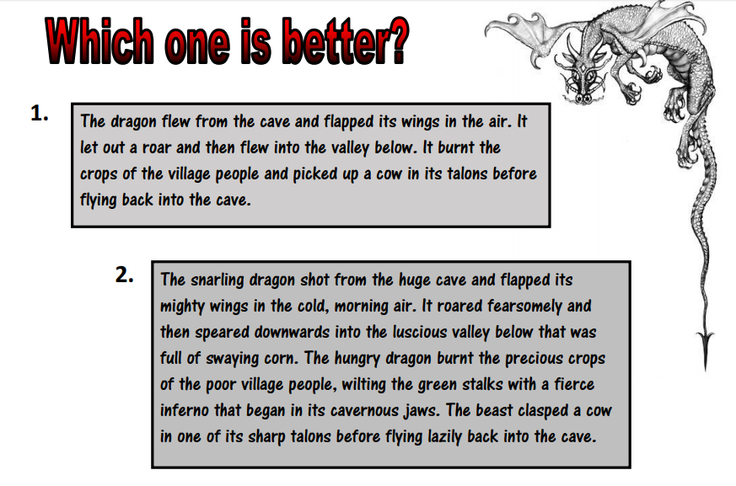
Read both descriptions and decide which is better. Then write your own description of a dragon using example 2. You may want to change the dragon to a different character for an additional challenge.

