How To Make a Pirate Hat.
Have you ever wanted to sail the seven seas? Follow the instructions below to help you prepare for the journey.
You will need:
A large rectangular piece of paper (newspaper is ideal).
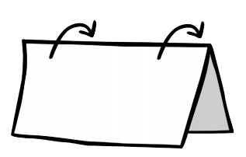
Method:
- First fold the paper in half carefully.

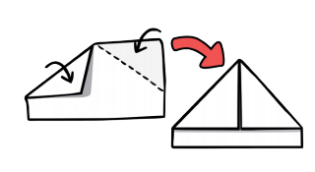
- Next, fold over the top corners so they
meet in the middle.

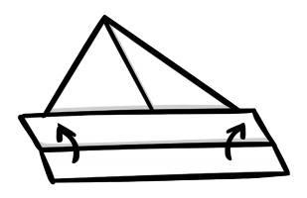
- Lift up the front flap at the bottom and
fold.

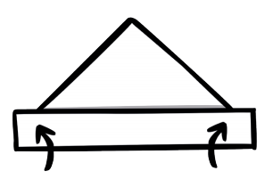
- After that, flip the paper over and repeat.

- Finally, put on your hat and shout ‘ARRRRR!’

Now you are ready to board your ship. Be careful, there could be sharks in the water.

