**Woodhorn Colliery Museum Tuesday 10th July.**

On Tuesday morning the doors to Reception will be open so children can come straight in without lining up on the yard as we aim to leave promptly following register. Children should wear **school uniform** and **sensible shoes**, a **sun cap** and a **rain coat**. **Please can all children have sun cream applied at home before school.** The children will be provided with a packed lunch from school which will include water but they will need to **bring their water bottles** to keep them hydrated throughout the day. We aim to be back in school before the end of the school day so pick up is usual time.

**Parent Helpers.**

Many thanks to our parent volunteers. Parent volunteers should meet at school to car share and follow behind the coach. Parents will need to bring their own packed lunch and drinks as the cafe will be closed. Can we please ask that parents do not bring sweets.

**Teddy Bears Picnic Thursday 12th July.**

On Thursday we are looking forward to getting together with Nursery for a Teddy Bears Picnic where we will have a story, a sing song and a small snack. Our school cook has kindly offered to provide us with party snacks. It would be lovely if your child could bring a teddy to school that day with a named label on to prevent it from getting mixed up and separated from their owner.



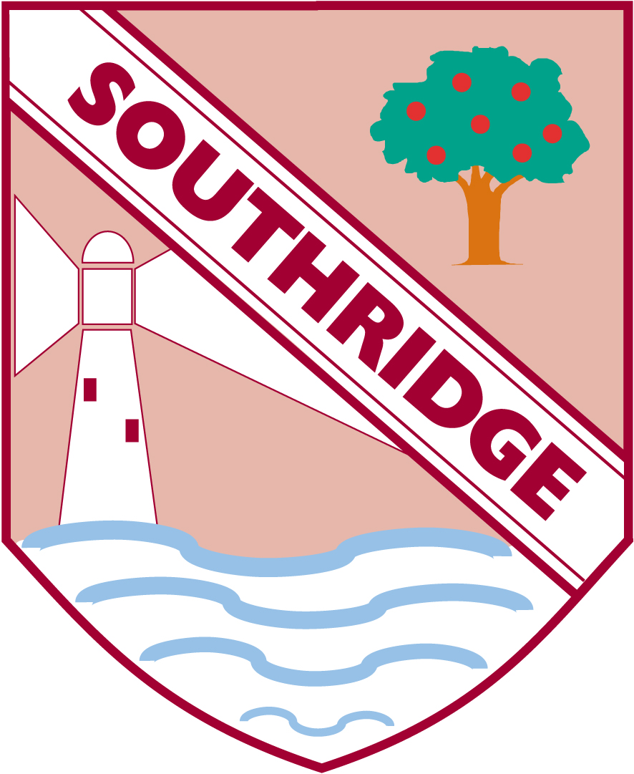

**Reception Newsletter: 6.7.18**

**Meet the Teacher 11th July Wednesday.**

We were incredibly proud of the children when they went off to spend some time in Year 1 with their new teachers this week. They were all very grown up and the Year 1 staff thoroughly enjoyed their time together.

There is opportunity for parents to meet Year 1 Teachers on Wednesday at 5pm in the school hall.

**Teddy Bears Picnic Thursday 12th July.**

On Thursday we are looking forward to getting together with Nursery for a Teddy Bears Picnic where we will have a story, a sing song and a small snack. Our school cook has kindly offered to provide us with party snacks. It would be lovely if your child could bring a teddy to school that day with a named label on to prevent it from getting mixed up and separated from their owner.