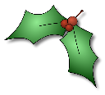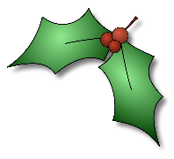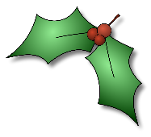

**Reception Newsletter: 11.12.20**

We will be sending a reading challenge home for the holidays and collecting books in on Monday for auditing. Please make sure the children have their reading books in their bags.

As mentioned in a previous newsletter we will be sending wetsuits and PE bags home next week too. Please consider providing a warmer wetsuit for the winter season as it can get chilly in our yard.

A big thank you to yourselves too for taking time to help your child/ children write their Christmas cards, both classes have been very patient waiting for their cards to be delivered after isolation with the elves.

Have a lovely weekend and we will see you on Monday.

Important information







Next week we are having a ‘Crafty Week’ to strengthen fine motor skills, build problem solving skills and explore creative talents. The children will love the different activities. This has been their first full term in school and Autumn term is the longest. We are so proud of their resilience and positivity. Well done children!

What a wonderfully festive week we have had in Reception. There have been more tales about the elves at home and fun to be had in the Christmas Post Office, Santa’s Grotto and the Elves workshop. Our Christmas Party Day was a fantastic and exciting way to end the week, playing games, dancing, sharing lots of laughter and making good memories.

We would like to say a big thank you to the ‘Friends of Southridge’ for providing beautifully wrapped bags of sweet treats for each child to take home on party day. The parent’s group have also purchased a lovely craft activity for the children to enjoy next week before we break up for the holidays.

Please keep emailing your wonderful observations from home. These make super additions to your child’s learning journal and contribute towards their Early Learning Goals. There is a PowerPoint on the Early Years section of the school website that provides advice on how to capture observations at home and the importance of ‘the child’s voice’.



