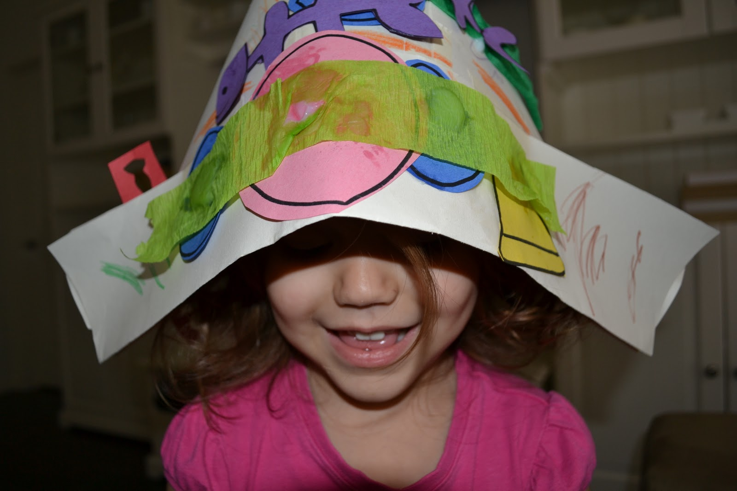

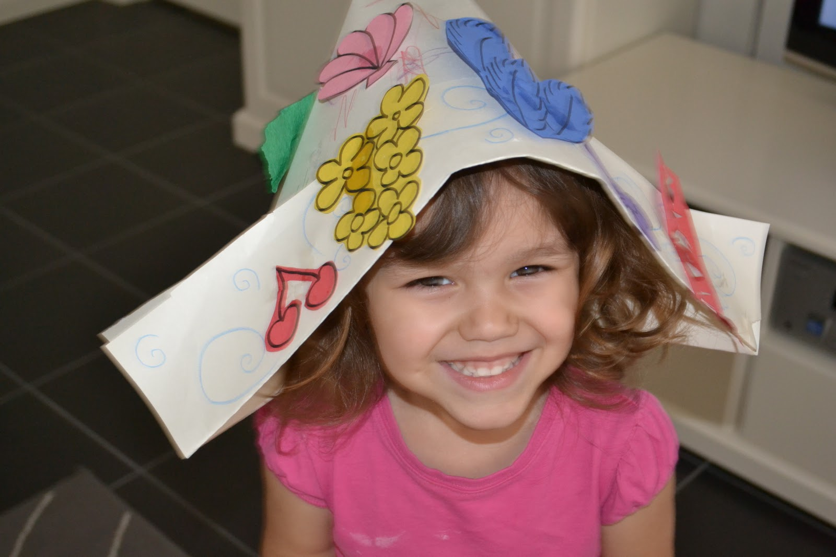

How to Make a Hat.

|  |  |
| --- | --- |
| 1. Use a large piece of paper or a sheet of newspaper. | 1. Fold the paper in half.   C:\Users\Admin\Desktop\Home\Mrs Honey's Hat\2.JPG |
| 1. Fold over the top corners so they meet in the middle.   C:\Users\Admin\Desktop\Home\Mrs Honey's Hat\3.JPG C:\Users\Admin\Desktop\Home\Mrs Honey's Hat\5.JPG | 1. Lift up the front flap at the bottom and fold.   C:\Users\Admin\Desktop\Home\Mrs Honey's Hat\6.JPG |
| 1. Flip the paper over and repeat.   C:\Users\Admin\Desktop\Home\Mrs Honey's Hat\7.JPG | 1. Decorate your hat.   C:\Users\Admin\Desktop\Home\Mrs Honey's Hat\8.JPG |