**Design a Funky Spiral.** Ask your grown-up to draw a spiral just like a snail shell. Now make your spiral extra funky by carefully finger painting dots along the line. You could make it more exciting by making a repeated pattern.

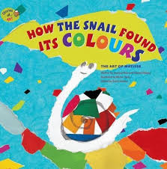

**Draw a Slimy Snail Trail**. Slimy Snail sets out on a trail. But where exactly does he go? Up a hill, over a bridge, down a slope. Make a map of where you have been and talk about position and distance. Did you go **under** the table? **Around** the couch? Or plan your trail ahead – where will you leave your silvery slimy messages?

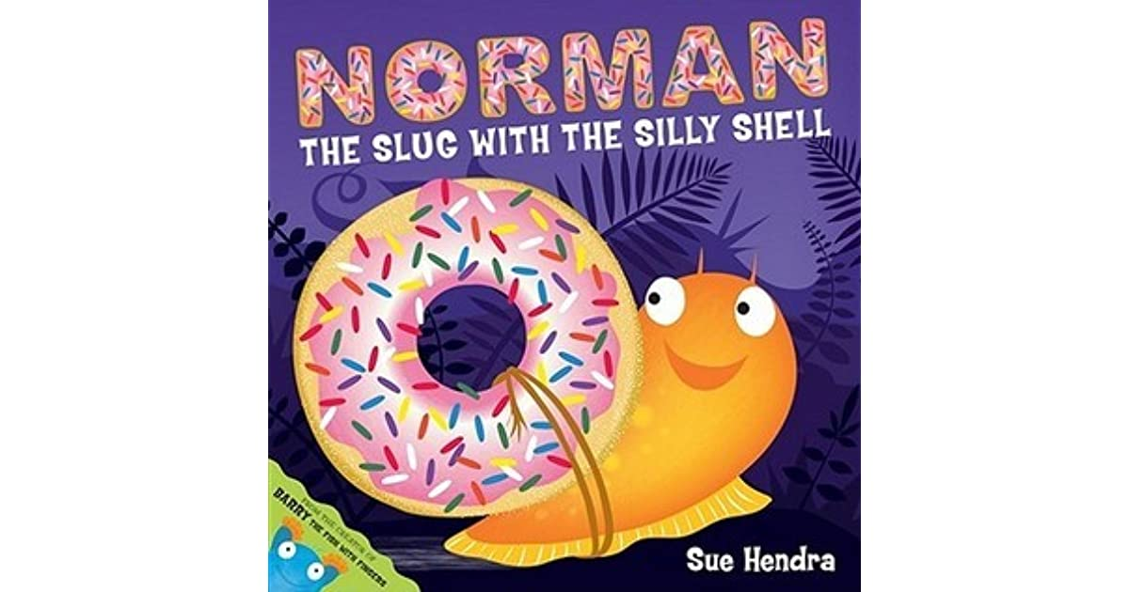

Listen to Mrs Waller read **Norman the Slug with the Silly Shell.** This story is about a slug who longs to be a snail and looks for his perfect shell.



**Home Learning Ideas**

**Week beginning:**

**15th June 2020**

**Make a collage like Matisse.**  
Cut and tear tissue paper or paper you have painted in different colours then arrange them to make a colourful collage picture. You might choose to make a snail or maybe something else.

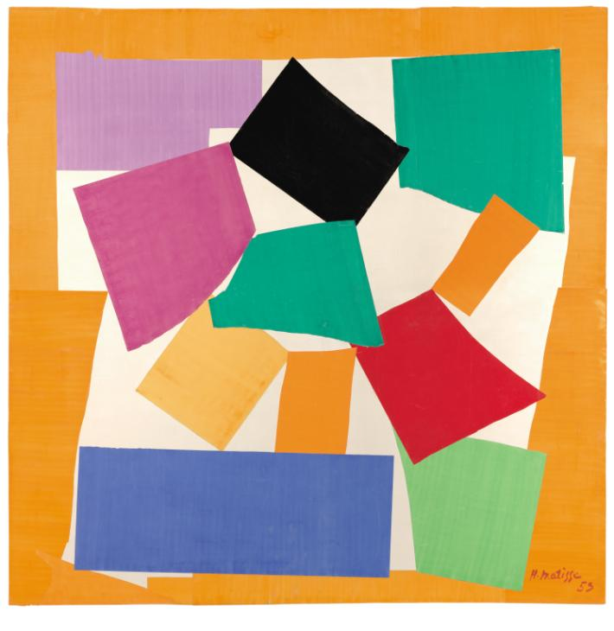



**Spiral snacks!** Follow the attached instructions to make your own edible snail shells!

Why not make up your own subtraction game by eating your snails?

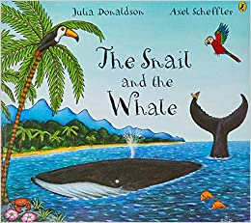

Listen to Mrs Scott read **The Snail and the Whale.** A tiny snail with 'itchy feet' hitches a ride on the tail of a 'great big, grey-blue humpback whale' and sets off on a fabulous adventure around the world.

Listen to Mrs Mason read **How the Snail Found Its Colours.** It’s all about a snail's search for the right colour for its shell and helps us understand how Matisse refined his technique and how the selection of particular colours and shapes was the key to his art.

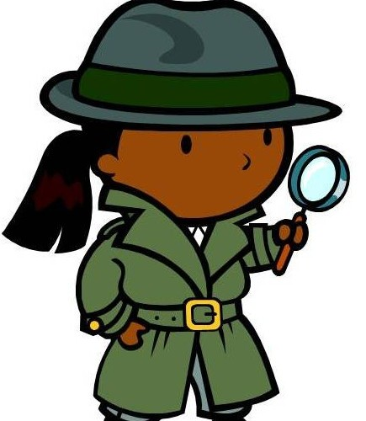

**Be a snail detective.** When you are out and about look out for snail trails on walls or paths together. If you spot some snails talk about what you see.

**Make your Own Spirals.**  **Watch the Wiggle and Squiggle video.** Spirals are a very special pattern. A pattern that happens naturally in nature. Have a go at making your own spirals. Start from the middle and get bigger and bigger! Different kinds of snail have different kinds of shell, some are small and round, some are long and thin. Have a look at the differences. Can you look for other patterns that happen in nature?

**Make a snail trail picture.**Dribble glue in swirls and lines onto a large sheet of (ideally dark coloured) paper then sprinkle glitter on top and shake off. This is a messy activity, so you will need to lay out plenty of newspaper before starting.

