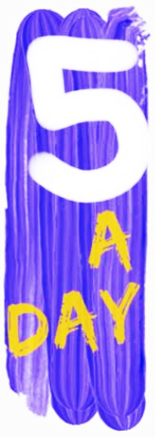 | Mathematics | Language and Literature | Health, Fitness and Wellbeing  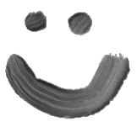 | Science and Nature  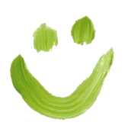 | Challenge of the Day!  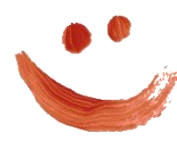
 | Treasure Map Game:  A great addition game for pirates of all ages!  CLICK HERE | Nutmeg, Spaghetti and Leaves!  Check out our daily selection of handpicked poems for EYFS, KS1 & KS2 to read and enjoy. Activities to try out are included.  CLICK HERE | Moments for the Mind: can you create a bug ‘hotel’?  CLICK HERE  Fit and Fabulous  Why not try the Joe Wicks workout today? 9.30 every day on YouTube! | May The Force Be With You:  How can rubbing a ruler change the behaviour of water?  CLICK HERE | Look around you - how many different types of technology can you see? Can you list or draw some? Choose one and talk to an adult about how life would be different if you didn’t have it. What would you use instead?
 | Metro Challenge: a collection of puzzles based on Tyne and Wear Metro. Ready for a trip?  CLICK HERE | The Heart and the Bottle, by Oliver Jeffers  It’s our Story of the Day!  CLICK HERE | Moments for the Mind: colour sculptures.  Colour is such an emotionally evocative aspect of the world around us. Time to express yourself...  CLICK HERE  Fit and Fabulous  Have a go at the PE Teams’ Daily Challenge on Twitter? | Creature Feature:  Animals and Humans Discussion Activity:  CLICK HERE | Geography Quiz 1: Recycling  Answer the 10 questions - can you beat your friends?  CLICK HERE
 | Let’s talk about Maths:  A daily diet of slides and images to encourage chat and provoke deeper thinking.  Today’s chat includes a Cuboid Hunt…  CLICK HERE | Find the Right Read for your Child:  It can be difficult to know exactly what level your child is reading at, so this simple test has been created to help you quickly find out which Read with Oxford Stage suits your child best.  CLICK HERE | Moments for the Mind: Cloud formations. Get outside, lie back, look up...  CLICK HERE  Fit and Fabulous  Talking of FABULOUS - join Strictly’s Oti Mabusse for an online dance lesson every day at 11.30 on YouTube. | A-Z Science Puzzle:  From Astronomy to ….Zoology? Can you find 26 Scientific words and terms?  CLICK HERE | Victorian Parlour Games - Get ready for some good old-fashioned fun with these nineteenth century games. Play these games with your family and see if you can invent a better one.  CLICK HERE
 | Time for a Game!  Can you guess the hidden number after asking 5 clever questions?  CLICK HERE | Kettles, Worms and Butterflies!  Check out our daily selection of handpicked poems for EYFS, KS1 & KS2 to read and enjoy. Activities to try out are included.  CLICK HERE | Moments for the Mind:  Shadow puppets…  CLICK HERE  Fit and Fabulous  Sticking with shadows and Oti Mabusse.... ballroom dance outside and try to lose your shadow partner! | Marvin & Milo - Foil Boat. Can metal really float? Find out for yourself...  CLICK HERE | Make your own Museum - take a virtual tour of The British Museum CLICK HERE and find your favourite exhibit.  Then, with the help of a grown up, take photos of(or draw) 10 objects to go into ‘The Museum of You’. Can you explain why each object is so special to you?
 | Digit Card Challenge: arrange 9 cards to make a 2 x 3 digit sum add up correctly:  CLICK HERE | Get busy, Get dizzy  with our Daily Word Wheel :  There are 207 words that can be made.  There are 46 3-letter words; can you find them all?  Can you find the 8 letter word hidden in the wheel? Hint: You live there!  CLICK HERE | Moments for the Mind:  Spread a smile and remember your own smiley moments.  Fit and Fabulous  An oldie but a goodie… play a game of Tag. How can you change the rules so you don’t touch to tag?! | Ready for Launch?  See and tour the International Space Station!:  CLICK HERE | It’s hip to be Square!  Do the Square Number Challenge:  CLICK HERE
