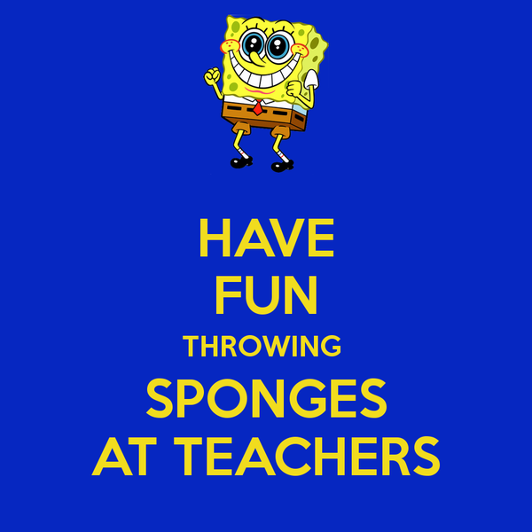

**Books!**

Can we ask that you have a look at home this weekend for books belonging to school and return them next week? Thank you.

**Magazines and comics**.

Does your child have any magazines or comics that they are finished with? We would love to put them to good use in Reception and would be grateful if you would send them in.

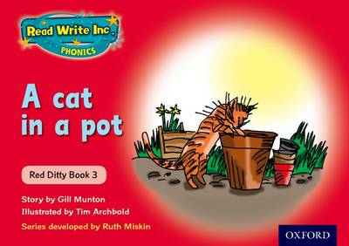

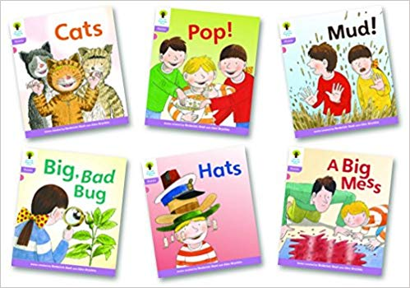

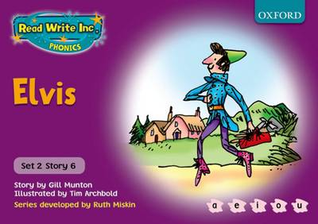

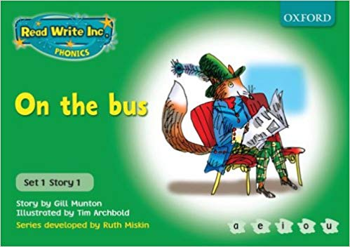

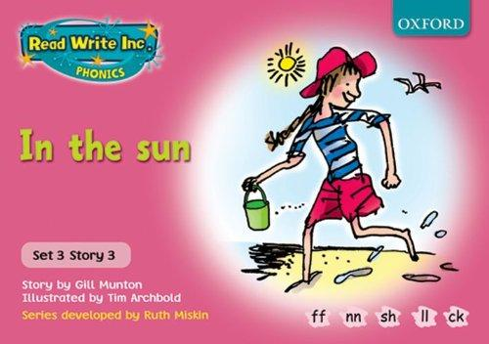

**End of Year School Report.**

Tonight you will receive your child’s end of year school report. May I ask you to take just five minutes to complete the parent’s comments sheet?

All staff work incredibly hard, teach and inspire your child and give such a high quality of care every day.

It is always good to hear about the things that you think we do well.

Thank you Tanya Parker (EYFS Lead).

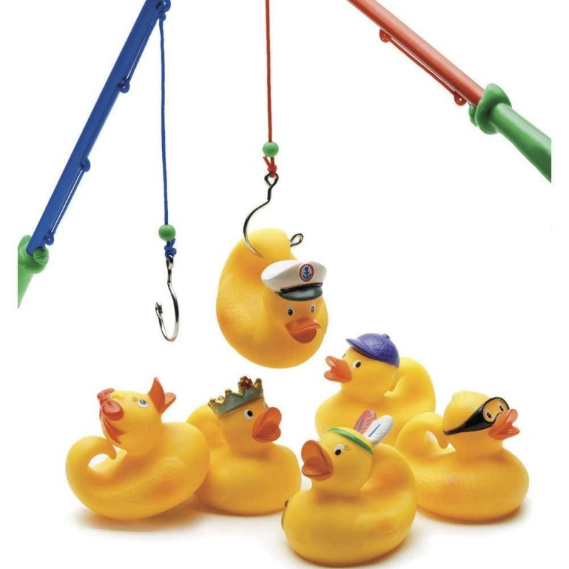



**School Fair.**

Please come along to the school fair on **Friday 12th July, 3.30 - 5.30**.

It’s sure to be a fun filled family event with plenty of activities and refreshments on offer including a bouncy castle, hook a duck, a steel band and lots more.

Someone said there would be wet sponges to throw at the Reception and Nursery teachers!! That can’t be right! Can it?

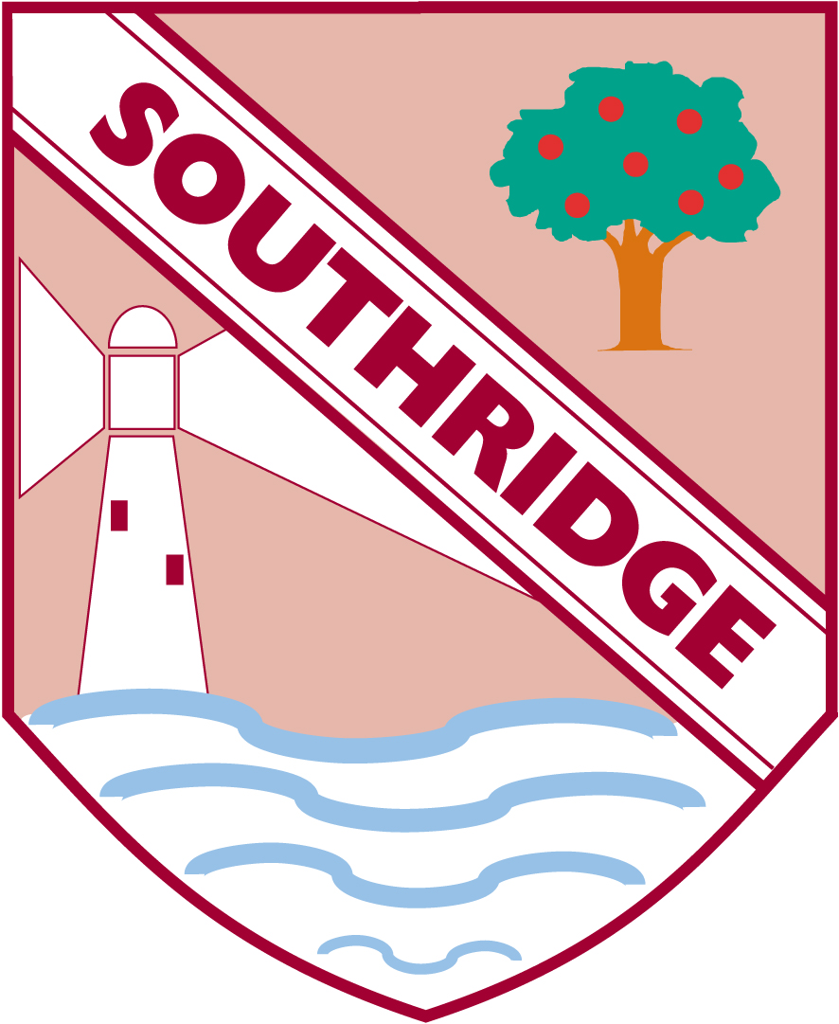

Southridge First School

Reception Newsletter 5.7.19