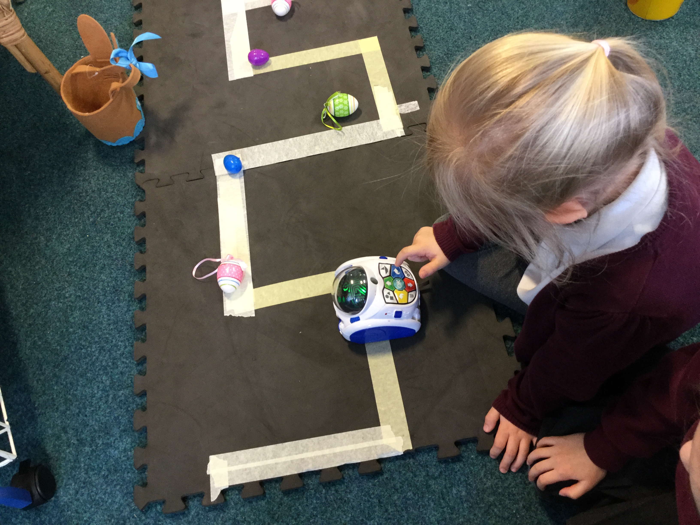

Thank you for all your positive feedback in the recent parent questionnaire. The analysis will be on our school website after Easter.

Finally, we hope our Reception Mums have

a lovely weekend and a very special Mothering Sunday.

Lego Club/ Cookery Club.

Clubs start again on the second week back after the Easter break and will run for four weeks. **Lego club starts** on **Wednesday 1.5.19** and **Cookery club starts** again on **Thursday 2.5.19**. A text message will be sent out to remind the parents of all children who are signed up for these clubs.

Lego Club.

There are four places left in Lego club for children who have not already tried it. If your child would like try Lego club this time please phone/visit/email the office. Children will be allocated a place on a first come first serve basis.

Hidden Heroes.

We would like to thank Eliza’s Mummy who came to visit us in school and told us about how she helps people in her job as an Educational Psychologist. Mrs Brook helped the children to understand that it’s really important to take care of their minds. We practised some relaxation techniques that we can use when we get big feelings that upset us and make us uncomfortable. We also talked about how important it is to get enough sleep and to drink lots of water to keep our brains hydrated.

Last week’s attendance winners were…

**Miss Parker’s class.**



Computer Workshop.

It was robots galore in Reception on Tuesday morning! Mrs Dodds from Computing for Kids brought her robots into school and set up lots of games for us play. The children thoroughly enjoyed the morning. They worked beautifully together in pairs and groups planning routes for the robots and programing them to collect things for us throughout their journeys. The children also used an app on the iPads to play a super game called Coding Safari, which they loved.



Southridge First School

Reception Newsletter 29.3.19