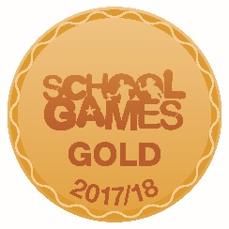
COMPETITION RESULTS 2017-18

AUTUMN 2017 | SPRING 2018 | SUMMER 2018
Rugby – Year 4  2nd | Fencing  2nd | Football – A team – 1st
Football – Year 3  Joint 1st | Quick Sticks Hockey  2nd | Hand Ball  2nd
 | Dodge Ball  2nd | Skipping  2nd Overall  Bronze – face to face skip  Silver – Girls speed bounce  Silver - Cross Over  Gold - Butterfly  Gold – Double Bounce  Gold – keep the Pot Boiling
 | Dance Festival | Handball – 2nd
 |  | Gymnastics
 | Skipping – Year 2  Gold – Best team | Cricket – 1st

